M. Eleanor (Waguespack) Loupe
May 4, 1897 – November 28, 1969

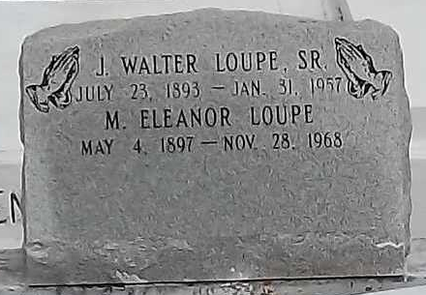
Photo by Mary Agnes Hammett

Marie Eleanor Waguespack Loupe, on Friday, November 28, 1969 at 5 o’clock a.m., wife of the late Joseph Walter Loupe, mother of Joseph Norbert, Kermit, Ernest, Allen, Ralph and Donald Loupe and Mrs. Ruffin Montz, all of Reserve, La. and Gerard Loupe of Seattle, Washington, sister of Mrs. Emile Villere and Mrs. Ferducie Schexnayder. Also survived by 44 grandchildren and 23 great-grandchildren. Age 72 years, a native of Edgard, Louisiana and a resident of Reserve, Louisiana.
Relatives and friends of the family are invited to attend the funeral. Services from Millet Funeral home, Reserve, Louisiana on Saturday, November 29, 1969 at 11 o’clock a.m. Religious Services at St. Peter Church, Reserve, Louisiana. Interment in Church Cemetery.

The Times-Picayune, New Orleans, Louisiana
Saturday, November 29, 1969, p. 18

