Marie (Blank) Loupe
August 28, 1929 – November 5, 2016

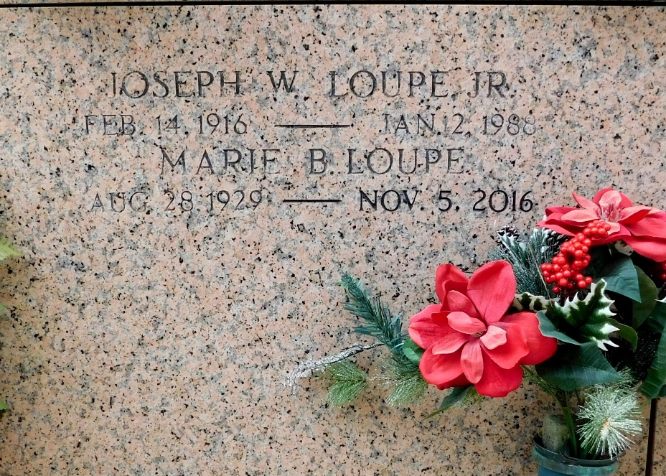
Photo by Mary Agnes Hammett

Marie Blank Loupe passed away on Saturday, November 5, 2016. She was 87, a native of Gramercy, LA and a resident of Paulina, LA.
Beloved wife of the late Joseph Walter Loupe, Jr. Mother of Warren Loupe, Sr. (Lorraine), Virginia Monroe (the late Charles), Brenda Maurin (George), Carolyn Toups (Lanny), Katherine Werhan (Kenneth), Wendy Stout (Morgan), Lois Loupe, Peggy Himel and Joseph Loupe, III (Leana).
Daughter of the late Blanche Braud and Hypolite Blank. Sister of Olymph ‘Teta’ Smith, Emilie Eliser and the late Bernard Blank, Ferrell Blank, Hypolite Blank, Jr. and Lelia Sims. Also survived by 27 grandchildren, 30 great-grandchildren, 28 great-great-grandchildren, 1 great-great-great-grandchild and many nieces and nephews.
Relatives and friends are invited to attend the Funeral Mass at St. Peter Catholic Church, 1550 Hwy 44, Reserve on Tuesday, November 8, 2016 at 11:00 a.m. Visitation at the church from 9:00 a.m. to 11:00 a.m. Interment in St. Peter Cemetery.

Millet-Guidry Funeral Home, LaPlace, Louisiana

