Norbert Peter Loupe Sr.
September 20, 1921 – January 22, 1997

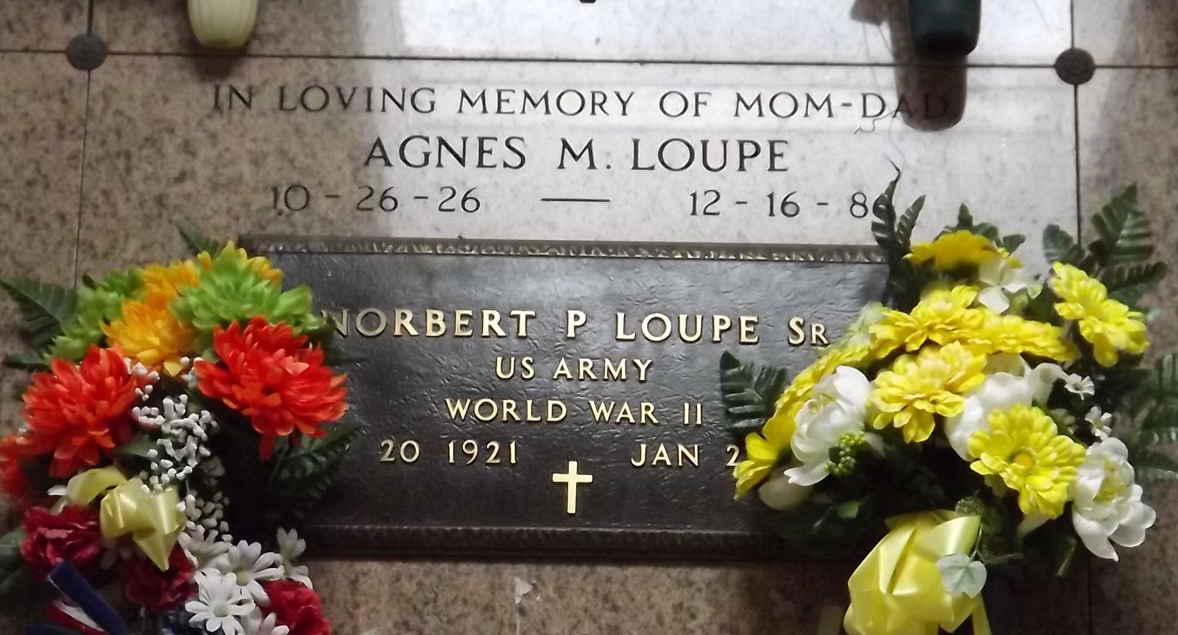
Photo by Mary Agnes Hammett

A resident of LaPlace for 32 years, he died at 8:05 a.m. Wednesday, Jan. 22, 1997. He was 75 and a native of Garyville.
Visiting at Millet-Guidry Funeral Home, 2806 W. Airline Hwy., LaPlace, 5 p.m. to 10 p.m. Thursday and after 8 a.m. Friday. Religious services at St. Peter Catholic Church, Reserve, at 10 a.m. Friday. Burial in church cemetery.
Survived by a daughter, Leana Nicholas; seven sons, Norbert Jr., Barry, Howard, David, Leonard, Thomas and Dennis Loupe; four daughters-in-law, Susan, Sue, Pam and Terry Loupe; 19 grandchildren, and 18 great-grand-children. Preceded in death by wife, Agnes Loupe Loupe.

The Advocate, Baton Rouge, Louisiana
Thursday, January 23, 1997

