David Louis Louque
August 20, 1953 – October 10, 2023

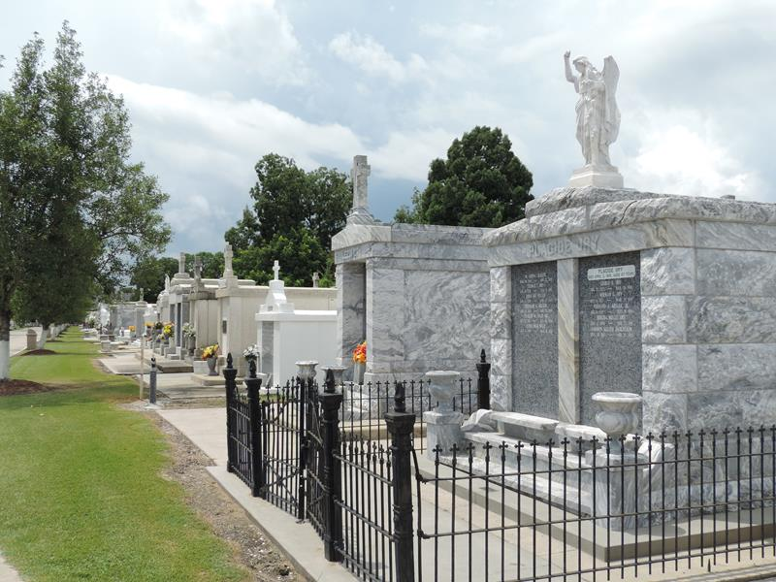

David Louis Louque entered into eternal rest Tuesday, October 10, 2023 at the age of 70, surrounded by his loving family. David was a native of Norco and a resident of Garyville.
He was welcomed into heaven by his loving parents, Julius and Lois Babin Louque, his brother, Kevin Joseph Louque, his sister, Sybil Loiacano and grandson, Steven David Louque.
David is survived by his devoted wife of 43 years, Patricia Miano, his sons, David Jr. (Bonnie), Kevin (Lacie), Sam and daughter Angela Hill (Jason). David leaves behind a legacy of love through his grandchildren: Kenneth, Declan, Elijah, Brianna, Savannah, Summer, Justin and Brenden.
He is also survived by his three brothers: Kenny (Doris) Louque, Gary (Staci) Louque and Barry (Wendy) Louque and his four sisters: Kitty (Whitey) Faucheux, Patty (Cabot) Corso, Carol (Milton) Maples and Donna (Chris) Maples.
The family would like to extend their deepest appreciation to Compassus Hospice Team for the care they bestowed on David on his final days.
Relatives and friends are invited to attend a Funeral Mass at 11:00 AM on Thursday, October 19, 2023 at St. Hubert Catholic Church, 176 Anthony F Monica Street, Garyville, LA 70051. Visitation will begin at 9:00 AM. Interment will be in St. Peter Cemetery, Reserve, LA.

Millet-Guidry Funeral Home, LaPlace, Louisiana

