Louis Pierre Louque
June 16, 1894 – June 27, 1973

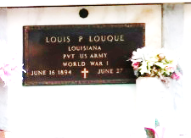

Funeral Services for Louis P. Louque Sr. were held at 10 a.m. Saturday, June 30 from the St. Peter Catholic Church in Reserve.
Mr. Louque, a native of Convent and a resident of Reserve, died at 8:10 p.m., Wednesday, June 27, when the car he was driving was struck by another on the River Road at Gramercy. He was 79 years old.
His wife, Effie Bruley Louque, preceded him in death. Survivors include three sons, Louis Louque Jr., Reserve; Murphy Louque, Garyville, and Junius Louque, New Orleans; and five daughters, Mrs. Neal (Geraldine) Comeaux, Reserve; Mrs. Anicet (Tessie) Kliebert, Garyville; Mrs. John (Essie) Loof, Metairie; Mrs. Warren (Willie Mae) Older, New Orleans, and Mrs. Charles (Eulesborne) Richardson of Virginia.
Twenty grandchildren and two great-grandchildren also survive.

Unknown newspaper clipping

