Carlton James Luminais
July 26, 1926 – July 16, 2019

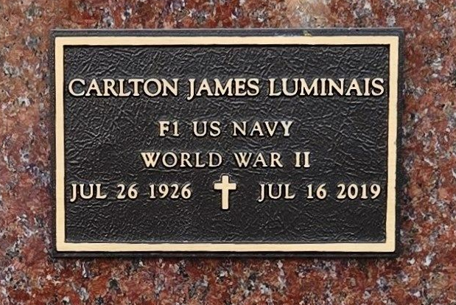
Photo by Team T-Lo

Carlton J. Luminais, a native and resident of Reserve, LA, passed away on July 16th, 2019 at the age of 92.
He is survived by his wife, Leatrice Landry Luminais; sons, Toby Luminais (Dionne), Timothy Luminais (Anna) and Steve Luminais (Sheryl); brother, Msgr. J. Anthony Luminais; grandchildren, Chad Guidry (Michelle), Brett Guidry (Michelle), Codi Naquin (Ben), Dana Milioto (Tommy), Shana Henry (Cliff), Steve “Stevie” Luminais, Jr. (Kassie), Travis Luminais (Lindsey), Sadie Politz (Sam) and Scott M. Luminais (Toni). Carlton is also survived by 22 great-grandchildren and 4 great-great-grandchildren.
Carlton was preceded in death by one daughter, Christine Luminais Guidry; his parents, Sidney and Leontine Vicknair Luminais, Sr.; brothers, Sidney Luminais, Jr. and Albert “Billy” Luminais and one great-grandchild, Francesca Banquer.
Fireman First Class Carlton J. Luminais proudly served in the US Navy on the USS Cecil during WWII in the battles of Iwo Jima, Okinawa and Saipan. He worked as an Electrician 1st Class at American Oil Co. in Destrehan and then worked for over 30 years at Kaiser Aluminum/LaRoche Industries Inc. in Gramercy.
The family would like to thank Twin Oaks Nursing Home, in LaPlace, LA, and their staff for their care and compassion given to Carlton during his time there.
Visitation will be on Saturday, July 20th, 2019 from 9:00am until 11:00am at St. Peter Catholic Church in Reserve, LA. A Mass of Christian Burial will be celebrated at 11:00am, and burial will follow in the church cemetery.

Rose Lynn Funeral Home, Lutcher, Louisiana

