Christine M. Luminais
June 5, 1950 – January 11, 2017

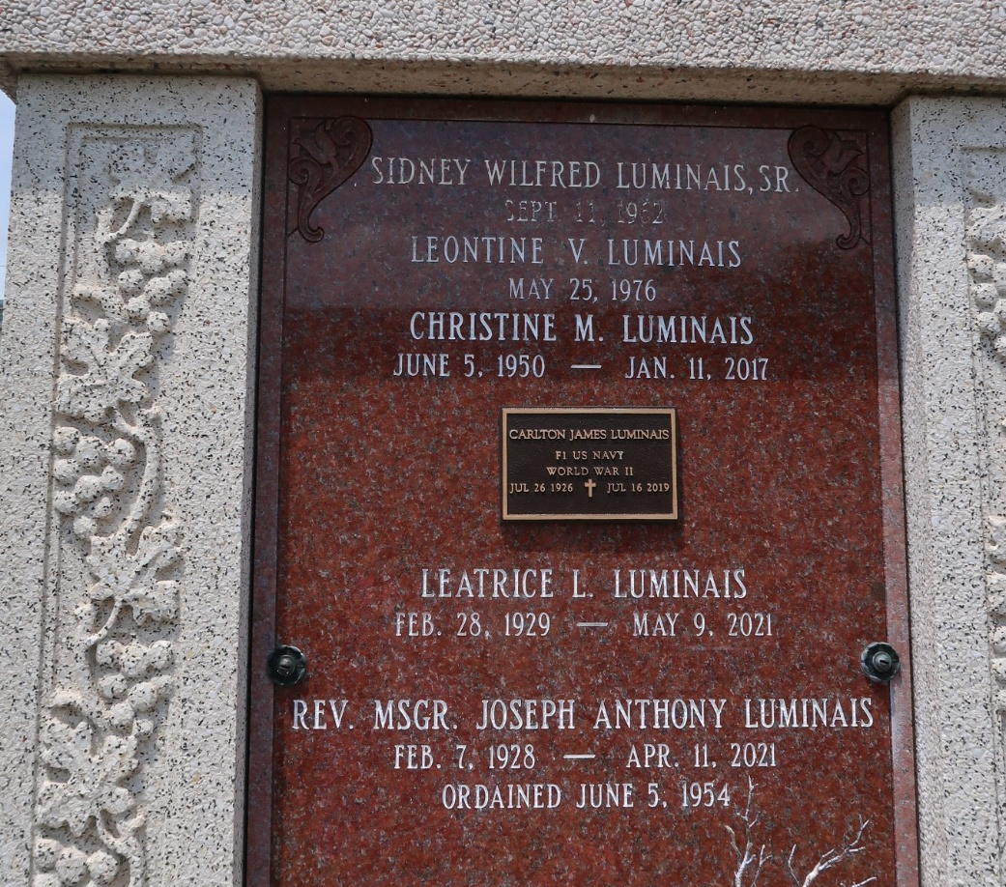

Christine Luminais Benson, age 66, passed away on January 10, 2017. She was a native of Reserve, LA and a resident of Lutcher, LA.
She is survived by her parents, Carlton and Leatrice Luminais; children: Chad Guidry, Brett Guidry, and Codi Guidry Naquin as well as her brothers: Toby Luminais, Timmy Luminais, and Steve Luminais. She leaves behind her grandchildren: Shawn, Taylair, Haylee, Brittney, Miley, Cassie, Kayley, L.J., Lexi, Brian and her great-grandchildren: Khloe, Rylie, Ryder, Kylie, and Hazel. She is preceded in death by her husband, Ferrell Benson.
Burial will be private.

Rose Lynn Funeral Home, Lutcher, Louisiana

