Geraldine (Perilloux) Luminais
February 23, 1933 – September 26, 2023

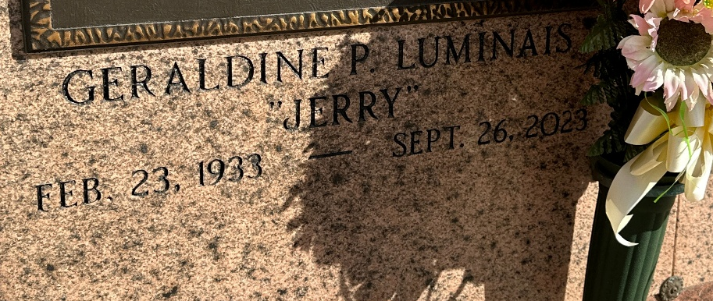
Photo by Team T-Lo

Geraldine “Jerry” Luminais passed away on Tuesday, September 26, 2023 at the age of 90. She was born in New Orleans, LA, a resident of Reserve, LA and recently resided in Gonzales, LA. Geraldine worked at Riverside Academy as an Elementary Teacher/Supervisor.
Beloved wife of the late Albert “Billy” Luminais. Loving mother of Brad Luminais, Sr. (Etta), Mike Luminais, Sr. (Robbie) and Missy Thomas (Tommy). Grandmother of Bradley Jr. (Brandy), Blake (Lindsey), Mike Jr. (Jill), Ryan (Hillary), Jonathan (Jamie), Katie LeLeux (Jarod) and Margo Thomas. Great grandmother to 12 great grandchildren. Daughter of the late Lawrence J. Perilloux and Kate T. Perilloux. Sister of the late Myrtle Levet (Leslie) and Gloria Perilloux.
The family would like to send a special thanks to her caregiver, Connie Vicknair, Francois Bend caregivers and administrators and Amedisys Hospice.
Relatives and friends are invited to attend the Visitation and Funeral Mass will be celebrated at St. Peter Catholic Church, 1550 Hwy 44, Reserve on Friday, September 29, 2023. Visitation at the church from 9:00 a.m. to 11:00 a.m. followed by a Funeral Mass at 11:00 a.m. Interment in St. Peter Cemetery, Reserve, LA.

Rose Lynn Funeral Home, Lutcher, Louisiana
September 29, 2023

