Rev. Msgr. Joseph Anthony Luminais
February 7, 1928 – April 11, 2021

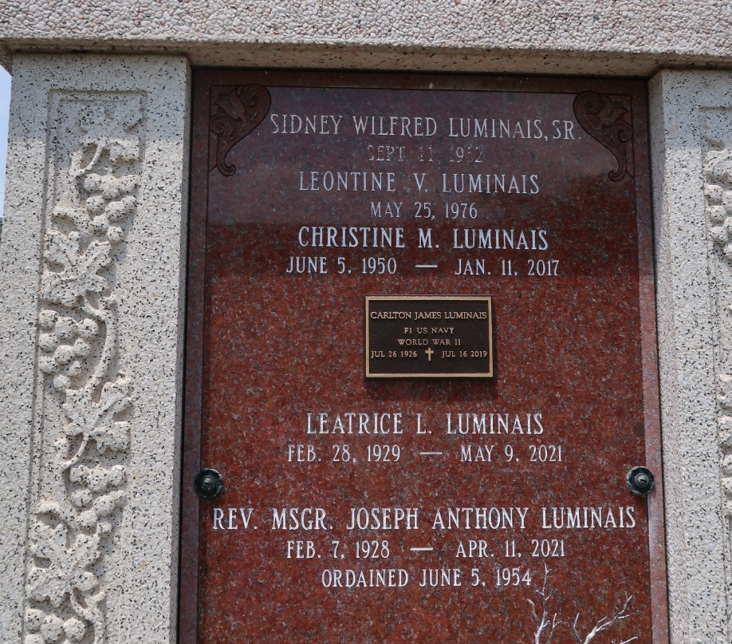

We are sorry to inform you that Reverend Monsignor Joseph Anthony Luminais, a priest of the Archdiocese of New Orleans, died on Sunday, April 11, 2021 at the age of 93. Msgr. Luminais was born on February 7, 1928 in Reserve, Louisiana. He attended elementary school at St. Peter in Reserve and his secondary education was at Leon Godchaux High School in Reserve, Louisiana. He attended St. Joseph Seminary, Covington and Notre Dame Seminary in New Orleans, and was ordained to the priesthood on June 5, 1954 in New Orleans. He received the Prelate of Honor on July 18, 1988.
Msgr. Luminais served as Assistant Pastor at Our Lady of Prompt Succor Church in Westwego and Our Lady of Lourdes Church in New Orleans. His pastorate was at Holy Guardian Angels Church in Bridge City, Louisiana. He also served as Chaplain at Southern Baptist Hospital in New Orleans, Secretary of the University Deanery, Chaplain of the Knights of Columbus Edward Douglas White Council #3246, Faithful Friar of the Knights of Columbus Very Rev. T. J. Larkin Assembly and Msgr. Paul J. Richard Assembly, Chaplain of the Knights of Columbus Msgr. Peter M.H. Wynhoven Council #3091, Assistant Spiritual Moderator of the Archdiocesan Council of Catholic Women and Moderator of the West Bank Deanery Council of Women. He organized the Bridge City Gumbo Festival and was known to many as the "Gumbo Priest". He also served as Past President of Louisiana Association of Fairs and Festivals. Msgr. Luminais was residing in Hanceville, Alabama at the time of his death. Well done, good and faithful servant.
Family, friends and parishioners of Holy Guardian Angels Catholic Church and Our Lady of Prompt Succor Catholic Church are invited to attend the visitation at Holy Guardian Angels Catholic Church, 1701 Bridge City Avenue, Bridge City, Louisiana on Tuesday, April 20, 2021 from 10AM until 12:30PM. A Funeral Mass will be celebrated at Our Lady of Prompt Succor Catholic Church, 146 4th Street, Westwego, Louisiana on Tuesday at 1:30PM. Interment will be held at St. Peter Cemetery in Reserve, Louisiana. In lieu of flowers, MASSES PREFERRED.
Respectful of current guidelines, all attendees must wear their own mask/face covering and practice distancing.
Mothe Funeral Home, Harvey, Louisiana

