Leatrice (Landry) Luminais
February 28, 1929 – May 9, 2021

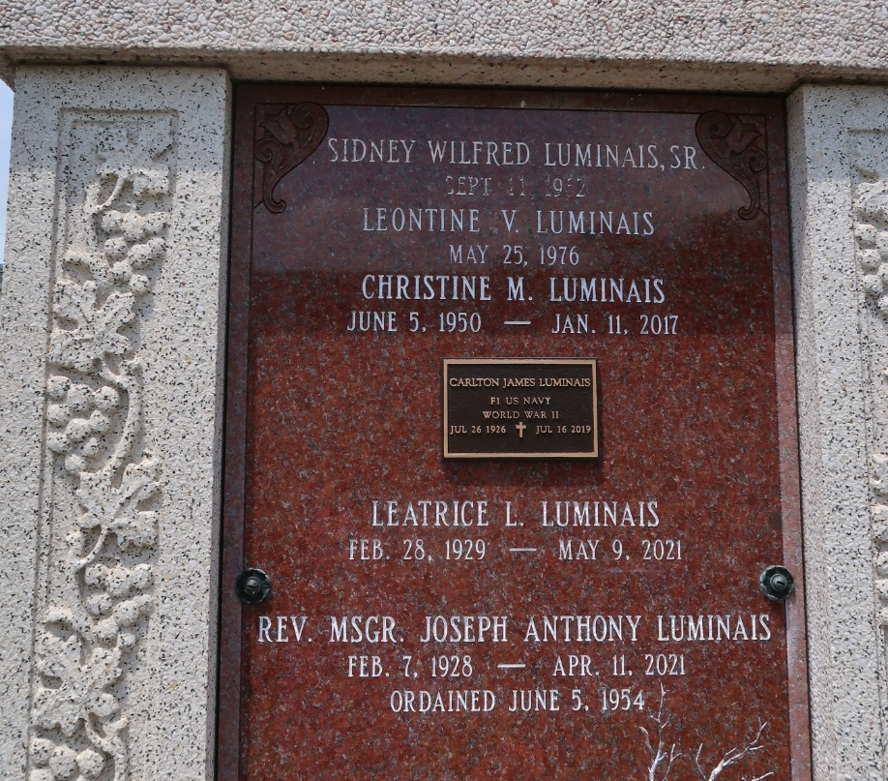

On May 9th, 2021, Marie Leatrice Landry Luminais passed away at the age of 92. "Lee" as she was known by everyone, was born February 28, 1929. She married Carlton James Luminais on July 1948 and they raised four children. Lee was a talented seamstress, excellent cook and a gifted baker and candy maker. She was also an exceptional wife and homemaker.
Lee was preceded in death by her husband of almost 72 years, Carlton, father Clifford Landry, mother Marcelle Montz Landry, brothers Clifford Jr, Mickey, Ronald, Bobby, Richard and survived by brother Roy and sisters Mary Gay, Sylvia, Sybil and Irene.
She is also survived by three children, Toby (Dionne) Timothy (Anna) and Steve (Sheryl) as well as deceased daughter Christine. 9 grandchildren; Chad, Brett and Codi Guidry, Travis and Sadie Luminais, Dana and Shana Luminais and Stevie and Scott Luminais. 22 Great grandchildren and 4 great-great grandchildren.
We would like to extend our thanks and appreciation to her caregivers at the Crossing residence for the love and excellent care they provided as well as to the Doctors, nurses and staff of Ochsner Main Campus.
Relatives and friends are invited to attend a Memorial Visitation for Leatrice on Wednesday May 12th 2021 from 9:30 a.m. to 11:00 a.m. followed by a mass at St Peter's Catholic Church on Hwy 44 in Reserve, LA. Interment to follow in the cemetery.
The Advocate, Baton Rouge, Louisiana
May 10 to May 12, 2021

