Daniel Adam Madere
August 5, 1901 – December 16, 1976

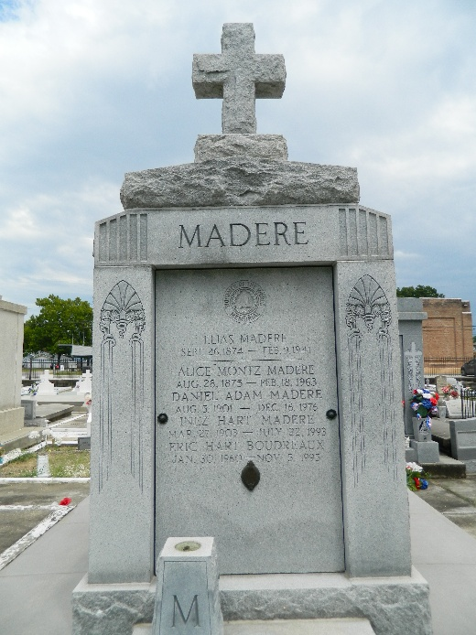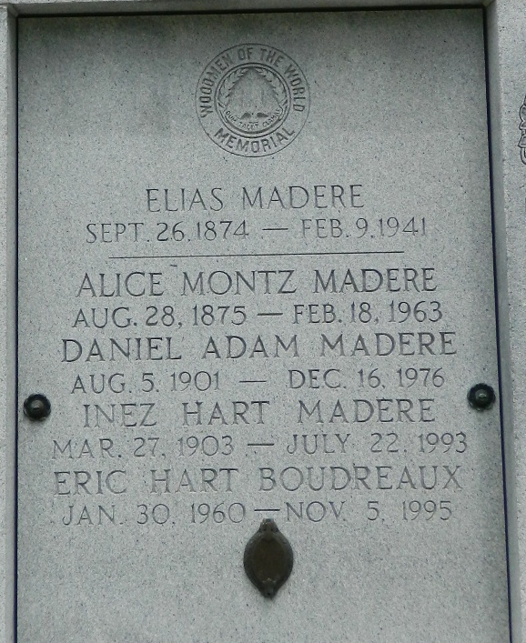

Age 75 years, a native and resident of Reserve, Louisiana. Husband of Mrs. Inez Hart Madere and father of Allynn Madere, Mrs. Jules (Inez) Millet Jr, Mrs. Paul (Danielle) Boudreaux and the late Mrs. Farrel (Rose Lynn) Aucoin, all of Reserve. He was the son of the late Mr. & Mrs. Elias Madere. Also survived by 14 grandchildren and 1 great-grandchild.

Services were Saturday 18 Dec 1976 at St Peter Church, Reserve, with interment in St Peter Cemetery.
The Times-Picayune, New Orleans, Louisiana
17 Dec 1976

