Denise (Guerret) Madere
May 20, 1895 – July 31, 1980

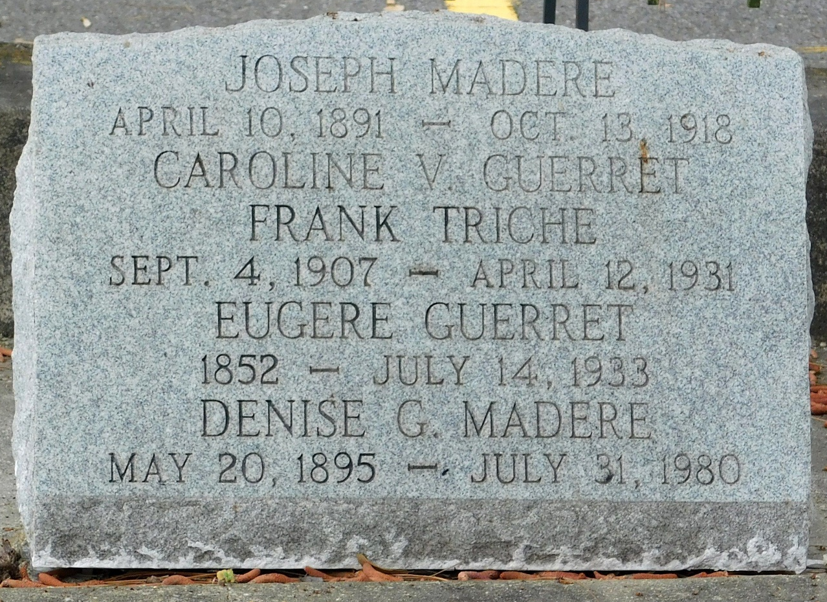
Photo by Mary Agnes Hammett

Wife of the late Joseph Madere, daughter of the late Euger (sic-Eugere) Guerret and Caroline Vicknair. She was the mother of Joseph A. Madere and the sister of Zoe Perilloux and the late Mrs. Emily Wurtzburger, Mrs. Henrietta Tonglet and Mrs. Lea Triche, Mrs. Feae Matherne, Miss Lucy DeLaneuville, August Vicknair and Homer Guerret.

Services were Saturday, 2 Aug 1980 with interment in St Peter Cemetery, Reserve, Louisiana.
The Times-Picayune, New Orleans, Louisiana
August 1, 1980

