Denise (Haydel) Madere
October 20, 1906 – November 24, 2002

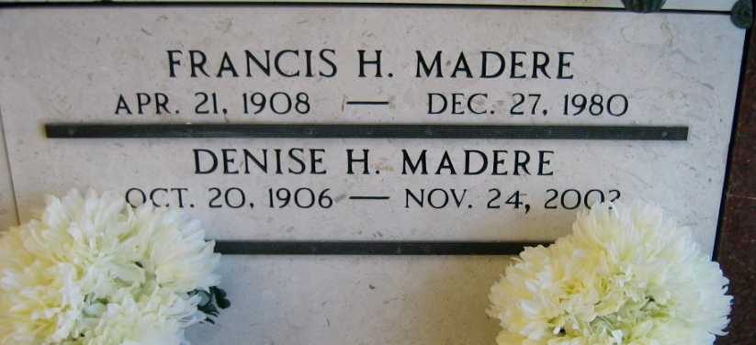
Photo by Bobby

Denise Haydel Madere on Sunday, November 24, 2002 at 10:42 AM. Beloved wife of the late Francis H. Madere. Mother of Frances Keating, Bertram Madere and Bryan Madere. Daughter of the late Edward and Eugenie Haydel. Sister of Stella Sutherland of Baton Rouge and the late Sister Francesca Haydel, Mrs. Lawrence Troxclair, Froisin Haydel, Mrs. Odile Luquette, Mrs. Lucy Oubre, Edward Haydel, Mrs. Leonie Loup, Mrs. Angie Faucheux and George Haydel. Also survived by 7 grandchildren, 7 great-grandchildren. Age 96 years, a native of Vacherie, LA and a resident of Reserve, LA for the past 65 years.

Visitation at St. Peter Catholic Church, Reserve, LA, on Wednesday, November 27, 2002 from 9 AM to 11 AM, followed the Mass of Christian Burial at the above church at 11 AM. Burial in St. Peter Cemetery, Reserve, LA. Arrangements by MILLET GUIDRY FUNERAL HOME, 2806 West Airline Hwy., LaPlace.
The Times-Picayune, New Orleans, Louisiana
November 25, 2002

