Edwin Guy Madere
December 15, 1923 – February 27, 2010

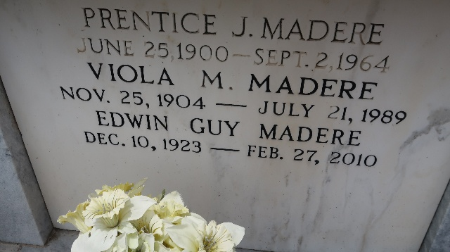

Edwin Guy Madere, a native and lifelong resident of LaPlace, died Saturday, February 27, 2010 in Baton Rouge where he had been in the care of his sister for the past four years. He was 86 years old and succumbed to Parkinson's. Guy graduated from Leon Godchaux High School in Reserve. He attended SLI in Lafayette before volunteering for the Army with his brother. They served in WORLD WAR II in Europe.
Guy worked many jobs until he found the job which was the love of his life. He was the Veteran's Services Officer for St. John the Baptist Parish where he helped many veterans and their families. He was a member of the V.F.W. and American Legion.
He is survived by his sister Laura Mae and her husband Harry A. Triche, also four nephews, four nieces and many great and great-great nephews and nieces and cousins. Preceded in death by his parents Prentice and Viola Madere, his brother Prentice Joseph Madere Jr. and his beloved grand- mother "Mamere Guy" Marie Davant Madere.
Relatives and friends are invited to attend services. Visitation at Millet-Guidry Funeral Home, 2806 W. Airline, LaPlace, La., on Tuesday, March 2, 2010 from 9:00 am to 11:00 am. Followed by a Mass in the funeral home chapel. Burial in St. Peter Cemetery, Reserve.
The Times-Picayune, New Orleans, Louisiana
March 1, 2010

