Elias Madere
September 24, 1874 – February 9, 1941

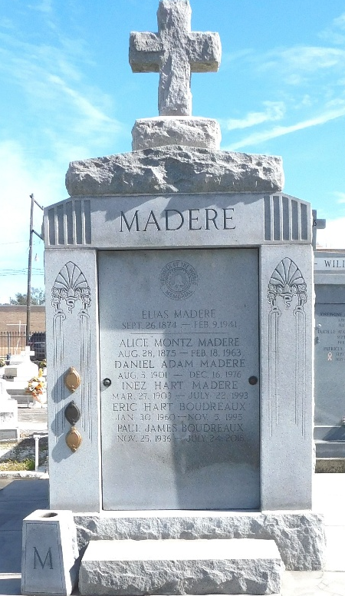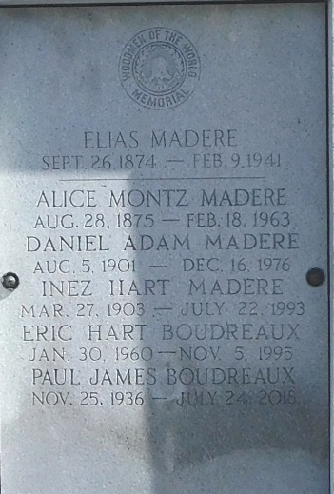
Photo by Mary Agnes Hammett

MADERE-At Reserve, La, on Sunday, February 9, 1941, at 5 o'clock p.m., ELIAS MADERE, beloved husband of Alice Montz, father of Glenn W and Daniel A Madere, brother of Mrs. Christopher Cox, also survived by 5 grandchildren, age 66 years.

Relatives and friends of the family, also officers and members of John A Reine Camp No. 504, W.O.W., are invited to attend the funeral, which will take place from the Jules Millet funeral home, Reserve, La. on Monday, February 10, 1941, at 4 o'clock p.m., followed by religious services at St Peter's church, Reserve, La. Interment St Peter's cemetery, Reserve, La.
The Times-Picayune, New Orleans, Louisiana
February 10, 1941, p. 2

