Inez Mary (Hart) Madere
March 27, 1903 – July 22, 1993

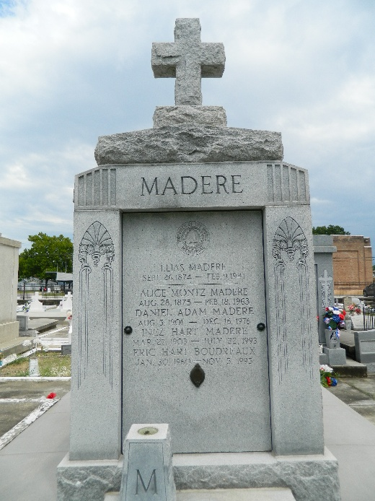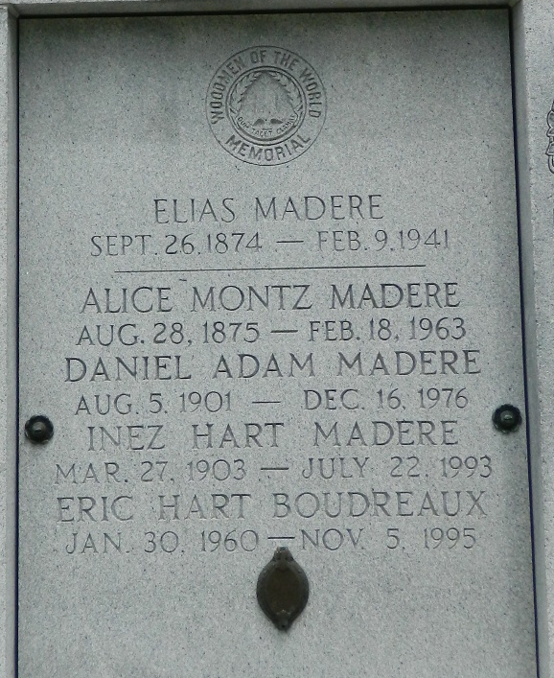

Age 90 years, a native and resident of Reserve, Louisiana. Wife of the late Daniel A Madere and mother of Inez M Millet, Danielle M Boudreaux, D Allynn Madere and the late Rose Lynn M Aucoin. Daughter of the late William Hart and Inez Belanger, sister of Dorothy H Hober and the late William B (Sweet), Ivey, Jessie, Frances (Buster), Louis, Ruth and Beulah Hart, Lillian H Malarcher and Helen H McHugh. Also survived by 15 grandchildren and 18 great-grandchildren.

Services were Saturday 24 Jul 1993 at St Peter Church, Reserve, with interment in St Peter Cemetery.
The Times-Picayune, New Orleans, Louisiana
July 23, 1993

