Joseph O. Madere Sr.
March 19, 1860 – September 30, 1914

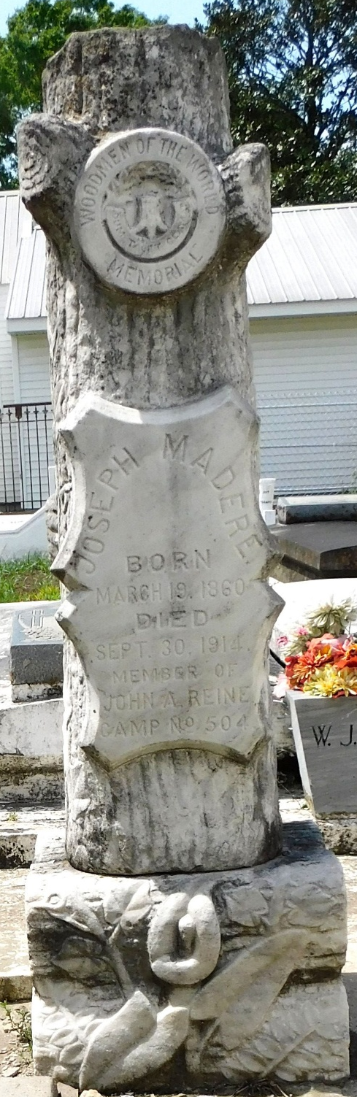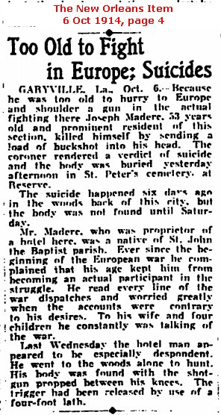
Photo by Mary Agnes Hammett Contributed by Dwayne Montz

