Louise (Prudhomme) Madere
November 19, 1887 – January 4, 1986

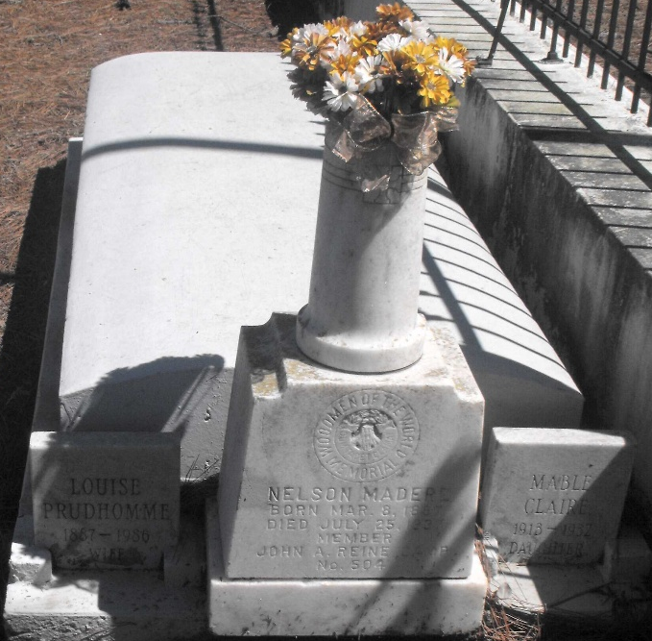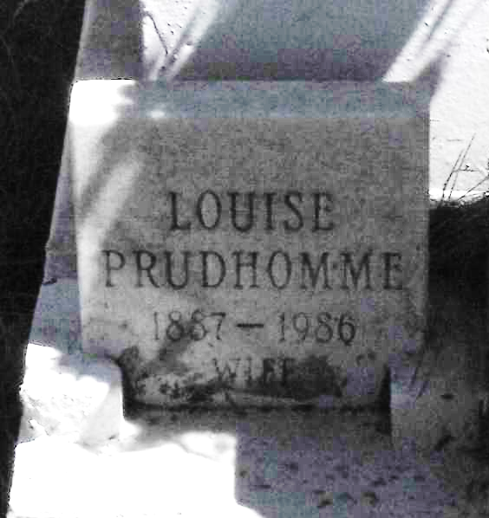
Photo by Mary Agnes Hammett

Age 98 years, a native of Campti, Louisiana, and a resident of Baton Rouge for 31 years. She was a retired St John the Baptist Parish, Louisiana, and Our Lady of Mercy Catholic School teacher.
Survived by two daughters, Josie Jacob of Baton Rouge, and Cleo Aniello of Hartford, Connecticut, 12 grandchildren and 16 great-grandchildren.
Preceded in death by her husband, Nelson Madere, and son Charles Nelson Madere.
Services were Monday 6 Jan 1986 at Our Lady of Mercy Church, Baton Rouge, with interment in St Peter Church, Reserve, Louisiana.
The Morning Advocate, Baton Rouge, Louisiana
6 Jan 1986

