Marie Alice (Montz) Madere
August 28, 1875 – February 18, 1963

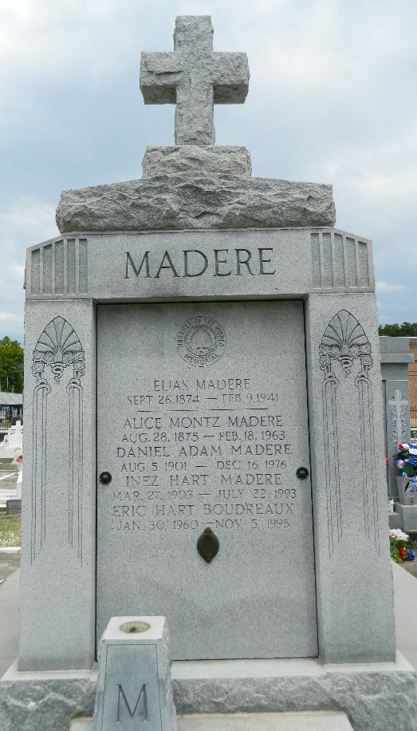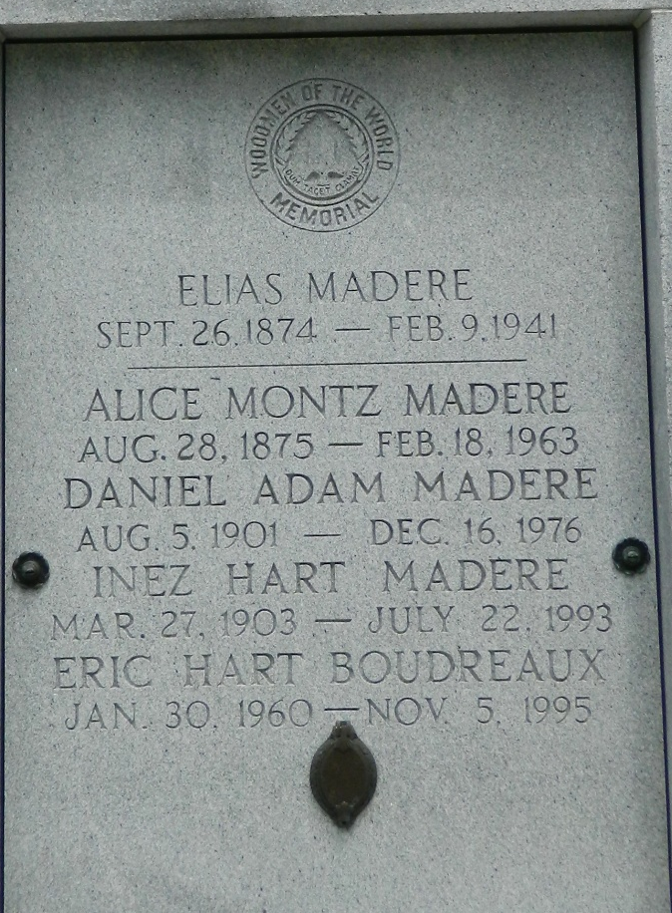

MADERE - On Monday, February 18, 1963, at 11:45 o'clock a.m., ALICE MONTZ, wife of the late Elias Madere, mother of Daniel A Madere of Reserve, La, and Glenn Madere of Opelousas, La, sister of Sister Mary Genevieve, O.P. and Armond Montz Sr of Laplace, La, and the late Mrs. George Lambert Sr, Marie, Corrine, Blanche, William, George and Octave Montz, also survived by 6 grandchildren and 21 great-grandchildren, age 87 years, a native and resident of Reserve, La.
Relatives and friends of the family are invited to attend the funeral. Services from Millet Funeral Home, Reserve, La, on Tuesday, February 19, 1963 a(t) 3 o'clock p.m. Religious services at St Peter Church, Reserve, La. Interment St Peter Cemetery.
The Times-Picayune, New Orleans, Louisiana
19 Feb 1963, p. 2

