Robert Pierre Madere
December 28, 1893 – September 9, 1956

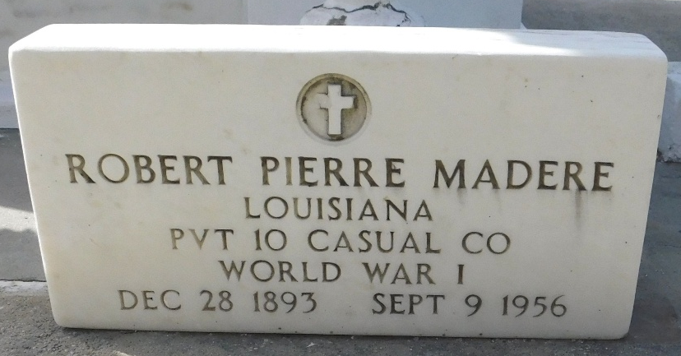
Photo by Mary Agnes Hammett

Robert Madere died at his residence in Laplace, Louisiana, on Sunday, 9 Sep 1956 at 10:40 o'clock PM. He was the husband of Simone Vicknair and the father of Robert and Judy Madere. Age 62 years, a native and resident of Laplace.

Relatives and friends of the family are invited to attend the funeral which will take place from Millet Funeral Home, Laplace, on Tuesday 11 Sep 1956 with religious services as St Joan of Arc Church, Laplace. Interment in St Peter Cemetery, Reserve, Louisiana.
The Times-Picayune, New Orleans, Louisiana
11 Sep 1956, p 2

