Veronica Ann (Robichaux) Maguire
December 10, 1942 – August 6, 2001

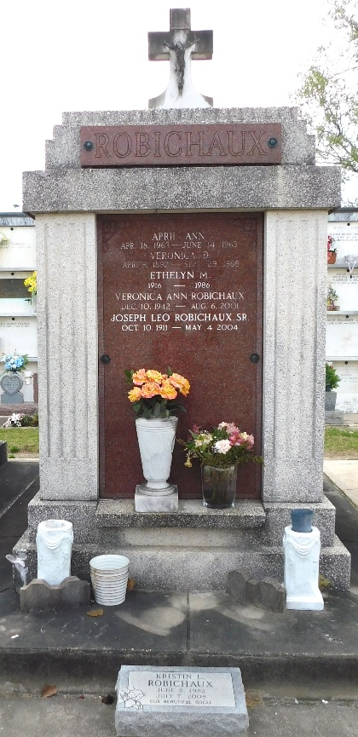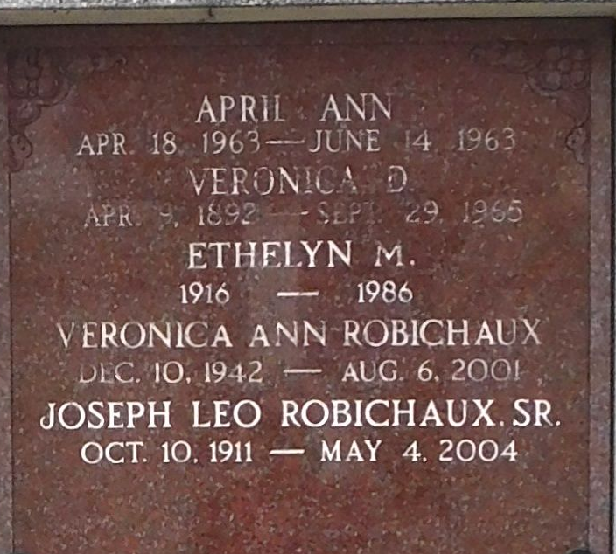
Photo by Mary Agnes Hammett

LAPLACE - Veronica Robichaux Maguire, 58, a native and resident of LaPlace, died Aug. 6. She was the mother of Pamela Thiem, Christine Bossier, Patrice Labit, Janelle and Timothy Breaux. She was the daughter of J. L. Robichaux, and the late Ethelyn Madere Robichaux, and sister of Peggy McKinney, Robert, J.L. Jr. and Lynn Robichaux. She is survived by 10 grandchildren.

Services were Aug. 10 in the chapel of Millet-Guidry Funeral Home, LaPlace, with interment at St. Peter Cemetery, Reserve.
L'Observateur, LaPlace, Louisiana
August 11, 2001

