Brian Paul Malbrough
June 4, 1950 – October 30, 2008

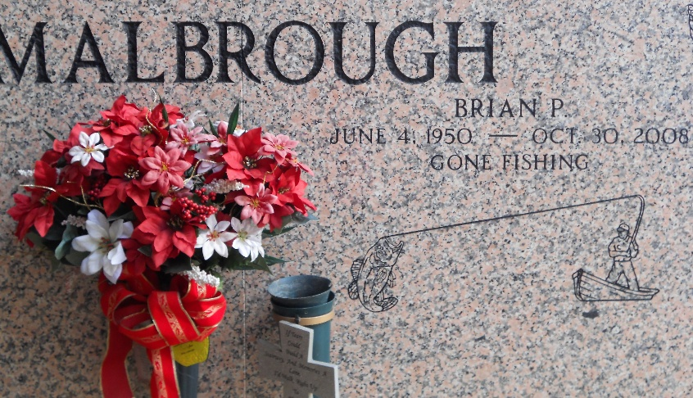
Photo by Team T-Lo

MALBROUGH - Brian P. Malbrough entered Eternal Life on Thursday, October 30, 2008 at 4:05 AM. Beloved husband of Patricia Troxlair Malbrough. Father of Todd Malbrough and wife Cori. Stepfather of Jennifer Scioneaux. Grandfather of Skyler, Abigail, Caden and Ryder. Son of Elaine Malbrough and the late Wilson Malbrough, Sr. Brother of Wilson Malbrough, Jr. and wife Cindy, Mona Veron and husband Austin and Sharon Murry and husband Ralph. Brother-in-law of Harry Troxlair.
Age 58 years. A native of Lutcher and a resident of LaPlace for the past 25 years.
Relatives and friends are invited to attend services. Visitation at Millet-Guidry Funeral Home, 2806 West Airline Hwy., LaPlace, LA, on Sunday, November 3, 2008 from 5:00 PM to 9:00 PM and on Monday from 11:00 AM to 1:00 PM. Followed by Religious Services at the Funeral Home Chapel at 1:00PM. Burial in St. Peter Cemetery Reserve, La.
The Times-Picayune, New Orleans, Louisiana
Nov. 1, 2008

