Earl Joseph Mannina
March 18, 1936 – January 30, 2023

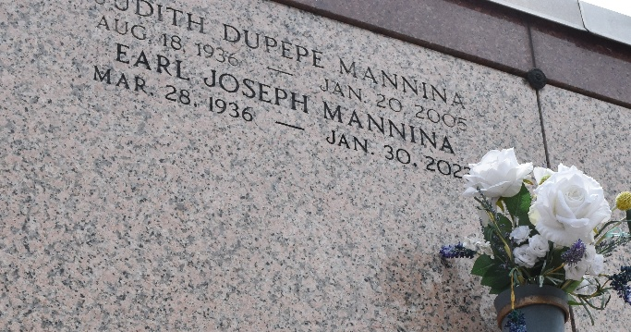

Earl Joseph Mannina went to his eternal reward on January 30, 2023 at 8:30 p.m. A native of New Iberia, La. and a resident of LaPlace, La. for 25 years. Age 86.
He was preceded in death by his parents, Nick and Agnes Mannina; sister, Mary Ann Mannina Kern; and his beloved wife of 28 years, Judith Dupepe Mannina. Survived by one son, Dean Mannina and wife Janet and two grandsons, Nicholas and Ryan Mannina; sister-in-law, Carol Dupepe; and several nieces and nephews.
Earl was a retired educator who served children for 31 years. He taught at Catholic High School-New Iberia, Bank Street Elementary, and North Lewis Street School, New Iberia, Archbishop Rummel High School, Metairie, La. He was assistant principal at Antonian High School, San Antonio, Tx, assistant director and instructor at Jefferson Parish West Bank Vocational school, Harvey, La. Mr. Mannina was principal at Sacred Heart Elementary School, Norco, La., St. Charles Borromeo High School, Destrehan, La., Christ the King Elementary School, Terrytown, La., and St. Peter Chanel Elementary School, Paulina, La. He was a Eucharistic Minister, Lector, and active member of St. Joan of Arc Church, LaPlace, La.
Earl was a member of the LaPlace Chapter of the AARP and served on the AARP Board of Directors. He was the tour coordinator for the monthly casino trips. He was a volunteer in the surgery waiting room at River Parishes Hospital in LaPlace, La. Earl was also a volunteer at the Southeast Louisiana War Veterans Home from 2005 until the time of his death.
Visitation and a Memorial Mass will be held on Wednesday, February 8, 2023 at St. Joan of Arc Catholic Church, 529 W. 5th St., LaPlace. Visitation will be held from 10:00 a.m. to 12:00 p.m. with the Mass to immediately follow. Burial will follow the Mass at St. Peter's Cemetery in Reserve, La.
Millet-Guidry Funeral Home, LaPlace, Louisiana
February 2, 2023

