Catherine Ann (Lions) Marino
April 18, 1943 – March 8, 2024

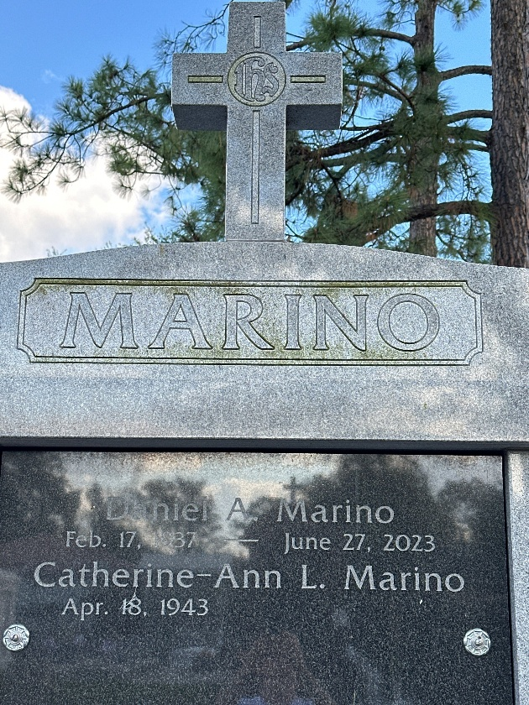
Photo by Team T-Lo

Catherine Ann Lions Marino passed away on Friday, March 8, 2024 at the age of 80. She was born in New Orleans, LA and a resident of LaPlace, LA.
Beloved wife of 54 years to the late Daniel Anthony Marino. Loving mother of Lacie-Ann M. (Joey) Brady and Danny (Brynda) Marino. Grandmother of Benjamin J. (Sarah) Brady, Rocco G. Marino, Lucca D. Marino, and Brodie Devillier. Great Grandmother of Grayson and Rynlee Brady. Daughter of the late Lucille Reine Lions and Louis E. Lions, Sr. Sister of the late Louis E. Lions, Jr., Cecil Jude Lions and Phyllis McCurley. Also survived by nieces and nephews.
The family would like to express their heartfelt appreciation to the Staff of Azalea Estates of Gonzales for their loving care.
Private Services were held.

Rose Lynn Funeral Home, Lutcher, Louisiana

