Daniel Anthony Marino
February 17, 1937 – June 27, 2023

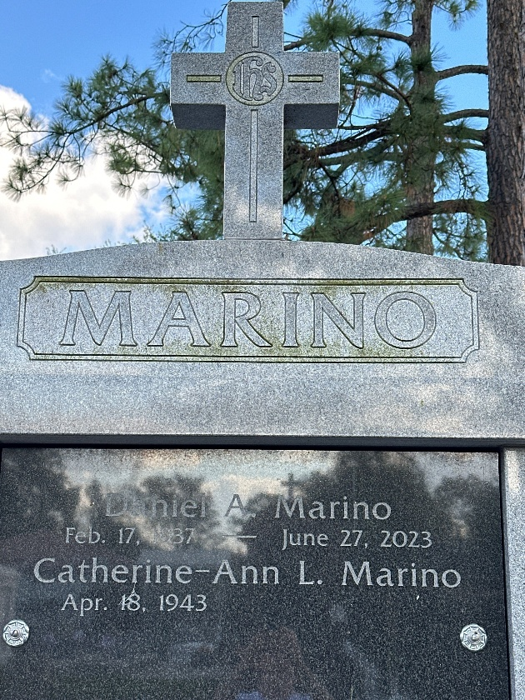
Photo by Team T-Lo

Daniel Anthony Marino passed away on Tuesday, June 27, 2023 at the age of 86 of natural causes. He was a life-long resident of LaPlace, LA.
Husband of Catherine-Ann Lions Marino for 54 years. Father of Danny (Brynda) Marino, and step father of Lacie-Ann M. (Joey) Brady. Grandfather of Benjamin J. (Sarah) Brady, Rocco G. Marino, Lucca D. Marino, and Brodie Devillier. Great Grandfather of Grayson and Rynlee Brady. Son of the late Tony Edward and Marie Florence Champagne Marino. Brother of the late Donald (Shelia)Marino, and Azilda Washbrun. Also survived by nieces and nephews.
Daniel proudly served in the U.S. Navy, and extended his service over 20 years as a U.S. Navy Reservist, reaching the rank of Petty Officer. He worked for EBASCO Services as a construction foreman, and later over 14 years as an inspector with the U.S. Department of Agriculture. He spent most of his life farming family property in the Crevasse, raising vegetables to be sold at the original French Market, and later at local grocery stores, or flowers that were sold to local florists. He also enjoyed spending long weekends of retirement at their lake house in Silver Run, MS.
Relatives and friends are invited to attend the Funeral. A Funeral Mass will be celebrated at St. Peter Catholic Church, 1550 Hwy 44, Reserve on Friday, June 30, 2023 at 11:00 a.m. Visitation at the church from 9:00 a.m. to 11:00 a.m. Interment in St. Peter Cemetery, Reserve, LA.
In lieu of flowers, donations can be made to St. Peter Parochial School, 188 W. 7th St., Reserve, LA 70084.

Rose Lynn Funeral Home, Lutcher, Louisiana

