Verlie Mim (Courville) Marks
August 16, 1934 – August 18, 2011

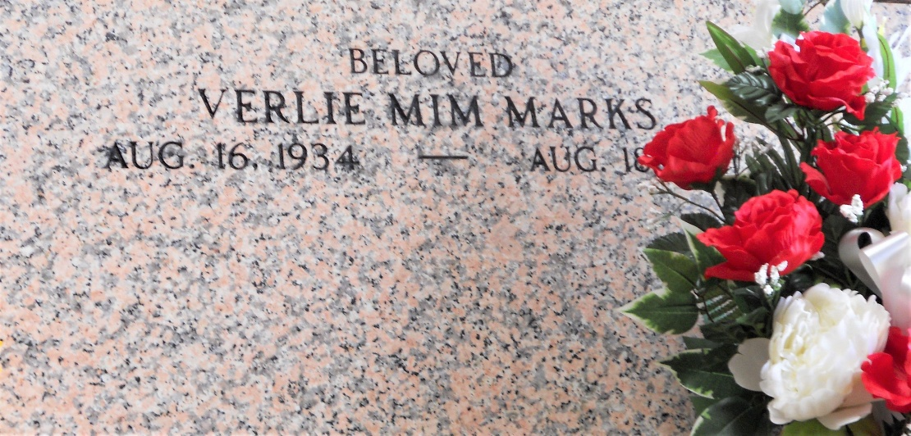
Photo by Team T-Lo

LAPLACE - Verlie Courville Marks passed away on Thursday, August 18, 2011. Beloved wife of Joseph Marks. Mother of Debbie Orgeron-Berthelot (Lawrence), Keith Marks (Ruth), Craig Marks (Dina), Jennifer M. Broussard (Brion) and Rhea M. Champagne (Jay). Also survived by 11 grandchildren and 8 great grandchildren. Daughter of the late Eta Wilks and the late Abraham Courville. Sister of Abraham Courville, Jr. and the late Johnny, Oleander and Nolan Courville, Onesia (Nan) Vidrine and Beatrice Bertrand. Also survived by nieces and nephews. Age 77 years. A native of Washington, LA and a resident of LaPlace.
Relatives and friends are invited to attend services. Visitation at St. Joan of Arc Catholic Church 529 W. 5th Street LaPlace on Saturday, August 20, 2011 from 9:00AM until 12:00 Noon followed by a Mass at the church at 12:00 Noon. Burial in St. Peter Cemetery Reserve, LA.
In lieu of flowers, Masses are preferred. Arrangements by Millet-Guidry Funeral Home LaPlace, LA.

Daily World, Opelousas, Louisiana
Aug. 21, 2011

