Estella Marie (Murry) Marse
March 8, 1908 – April 7, 2004

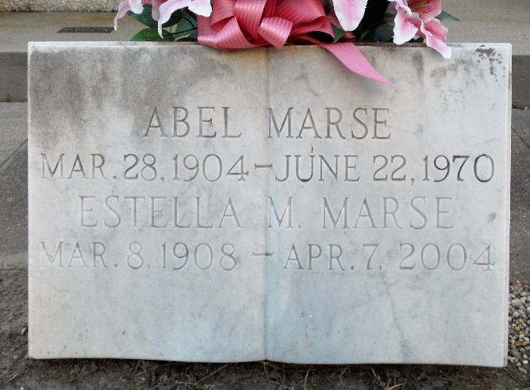
Photo by Team T-Lo

Estella Murry Marse on Wednesday, April 7, 2004 at 3:56 am. Beloved wife of the late Abel J. Marse. Mother of Emily M. Boudreaux, Thelma M. Vicknair, Clarence A. Marse and the late Norman, Sr. and Nolan Marse, Sr. and Jeanette M. Cambre. Mother-in-law of Betty Marse, Mary Ann Marse, Carol Marse, Eddie Cambre, Sr. And The Late Norman Boudreaux And Harry Vicknair. Daughter Of The Late Fabian And Cecile Murry. Sister Of Rita M. Becnel, Florence M. Holder, Joseph Murry And The Late Eniel, Adien, Fabian, Jr., Louis And Murphy Murry And Beulah Rome. Also Survived By 21 Grandchildren, 41 Great-Grandchildren And 8 Great-Great-Grandchildren.
Preceded In Death By 3 Grandchildren. Age 96. A Native Of Vacherie And A Resident Of Reserve For The Past 78 Years.
Relatives And Friends Of The Family Are Invited To Attend Services. Visitation At Millet-Guidry Funeral Home, 2806 West Airline Hwy., Laplace On Thursday, April 8, 2004 From 5:00 pm To 9:00 pm And On Friday From 9:00 am To 11:15am. Followed By Religious Services At St. Peter Catholic Church, Reserve, At 11:30 Am. Burial In Church Cemetery.
Times Picayune, New Orleans, Louisiana
April 8, 2004

