Jean Marse Sr.
December 13, 1922 – October 25, 2004

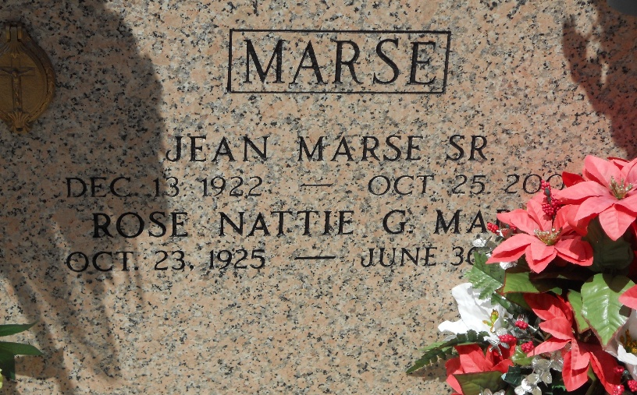
Photo by Team T-Lo

Jean (Dag) Marse, Sr., on Monday, October 25, 2004 at 9:15 a.m. Beloved husband of Rose Nattie Gondolfo Marse. Father and father-in-law of Jean, Jr. and Cynthia R. Marse, Kevin and Diana L. Marse and Yohanna and Gregory Lorio. Son of the late Arto and Agnes Brock Marse. Brother of Jeanne M. Folse (twin), Mary M. Humphries, Emma M. Schexnayder and the late Lester Sr., Pershing and Arto Marse, Jr. and Elvige M. Gravois. Grandfather of Darren and Jason Marse, Lisa Manzella, Brandy Quin, Jared and Jonathan Lorio. Great-grandfather of Natalie and Caroline Marse and Aiden and Noah Quin. Age 81. A native of Vacherie and a resident of Reserve for the past 63 years.
Relatives and friends of the family are invited to attend services. Visitation at St. Peter Catholic Church, Reserve on Wednesday, October 27, 2004 from 10:30 a.m. to 1:00 p.m. followed by religious services at the church at 1:00 p.m. Burial in church cemetery. Arrangements by Millet-Guidry Funeral Home, Laplace.
Times Picayune, New Orleans, Louisiana
October 26, 2004

