Norman Joseph Marse Sr.
August 23, 1929 – September 25, 2002

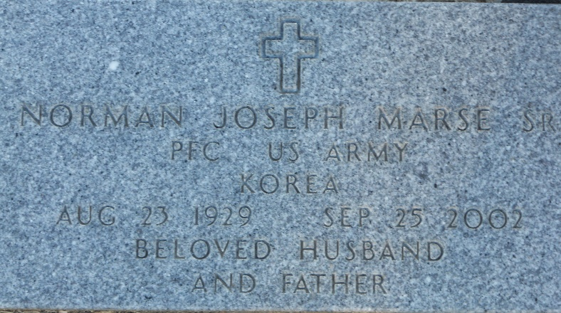
Photo by Team T-Lo

Norman (Fatty) Joseph Marse, Sr., on Wednesday, September 25, 2002 at 9:10 P.M. Beloved husband of Betty Ockmond Marse. Father and Father-in-law of Corwin and Babbette Marse, Natalie M. and Paul Dupre and Norman J. Marse, Jr. and his fiance' Angela Duhe. Preceded in death by his 2 sons, Christopher and Lawrence, his father, Abel, brother Nolan, Sr. and sister Jeanette M. Cambre. He is survived by his mother, Estella M. Marse, brother Clarence, sisters Emily Boudreaux and Thelma Vicknair, 7 grandchildren, 4 great-grandchildren and a host of nieces and nephews. He was godfather of Steven Marse.
Mr. Marse was a lifelong resident of Reserve, LA. Age 73 years. He served 2 years in The U.S. Army in The Korean War and was a 36th year employee of Godchaux-Henderson Sugar Refinery.
Relatives and friends of the family are invited to the visitation at MILLET-GUIDRY FUNERAL HOME, 2806 W. Airline Hwy, Laplace, LA. from 5 PM until 9 PM on Friday, September 27, and from 8 AM until 9:45 AM on Saturday, September 28. A Funeral Mass will be held at St. Peter's Catholic Church in Reserve, on Saturday at 10 AM. Interment immediately following the Mass in St. Peter's Cemetery.

The Times-Picayune, New Orleans, Louisiana
Sep. 27, 2002

