Rose Nattie (Gondolfo) Marse
October 23, 1925 – June 30, 2014

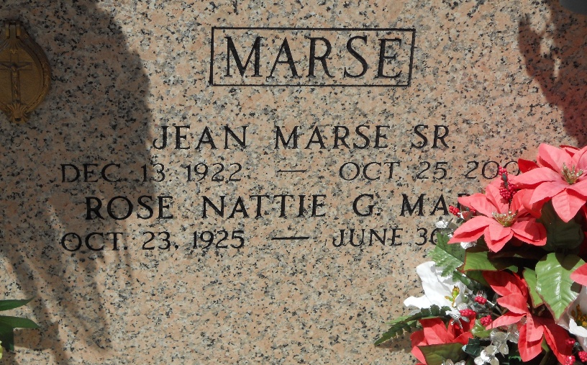
Photo by Team T-Lo

Rose Nattie Gondolfo Marse died on Monday June 30, 2014. Beloved wife of the late Jean (Dag) Marse Sr. Mother of Jean Marse Jr., (Cynthia), Kevin Marse (Diana) and Yohanna Lorio (Gregory). Grandmother of Darren (Angela) and Jason (Kris) Marse, Lisa Manzella (Brian), Brandy Quin (Tommy), Jared (Andrea) and Jonathan (Elise) Lorio and 8 great-grandchildren. Daughter of the late Saviat and Nattie Gondolfo. Step-daughter of the late Clement Frederick. Age 88. A native and resident of Reserve, LA.

Relatives and friends are invited to attend services. Visitation at Millet-Guidry Funeral Home, 2806 W. Airline Hwy., LaPlace, LA on Wednesday July 2, 2014 from 6:00pm to 8:00pm and on Thursday at St. Peter Catholic Church, Reserve, LA from 9:00am to 11:00am, followed by Mass at 11:00am. Burial in St. Peter Cemetery. In lieu of flowers donation preferred to St. Peter Catholic School, Reserve, LA.

New Orleans Advocate, Louisiana
Jul. 1 to Jul. 3, 2014

