Bibian (Huguet) Martin
December 13, 1908 – March 4, 1984
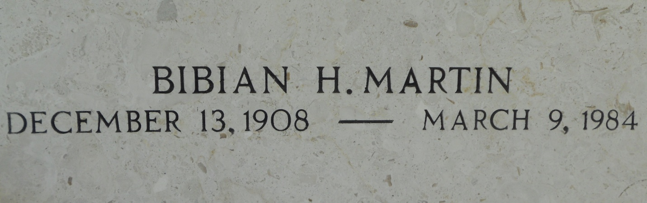
Photo by Team T-Lo

MARTIN

Mrs. Elzey (Bibian) Martin, Sr., on Friday, March 9, 1984 at 1:26 p.m., beloved wife of the late Elzey J. Martin Sr.; mother of E. J. Martin, Jr. and Larry Dale Martin, Sr., of LaPlace, LA; sister of Enola Dornier, of Baton Rouge, LA and Gurner Huguet, of Metairie, La, also the late Bruce and Gilroy Huguet; also survived by 8 grandchildren and 7 great-grandchildren. Age 75 years, a native of Convent, LA and a resident of LaPlace for the past 44 years.

Relatives and friends of the family are invited to attend the funeral. Services from Millet Funeral Home, LaPlace, LA on Monday, March 12, 1984 at 9:45 a.m. followed by religious services at St. Joan of Arc Catholic Church, LaPlace, LA. Interment in St. Peter Cemetery, Reserve, LA. Friends may call from 5 til 10 p.m. on Sunday, March 11, 1984 and from 8 a.m. until services on Monday.

The Times-Picayune, New Orleans, Louisiana
Sunday, March 11, 1984, p. 34

