Elzey J. Martin Sr.
March 5, 1907 – March 26, 1967

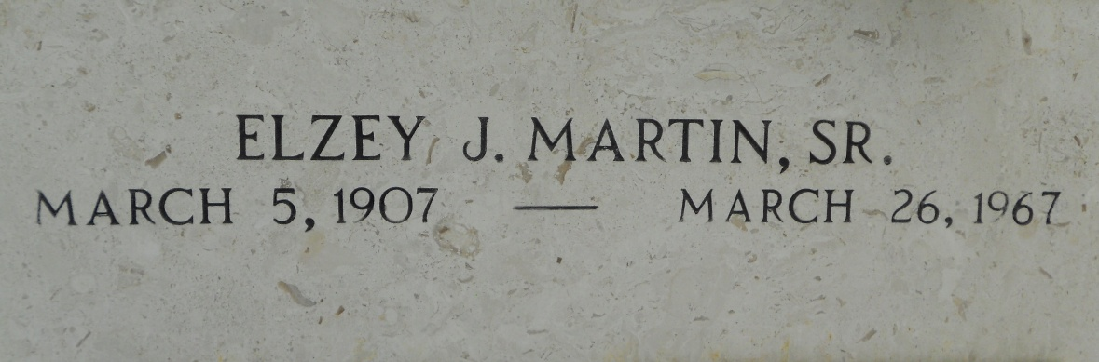
Photo by Team T-Lo

MARTIN – On Sunday, March 26, 1967, at 11;30 o’clock a.m., Elzey (E.J.) Martin Sr., beloved husband of Bibian Huguet, father of E. J. Martin Jr. and Larry Martin both of Laplace, Louisiana, son of Mr. and Mrs. Sigur Martin Sr., brother of the late Jared Martin; also survived by 7 grandchildren, age 59 years, a native of St. James Parish and a resident of Laplace, Louisiana for the past 25 years.

Relatives and friends of the family are invited to attend the funeral. Services from Millet Funeral home, Laplace, Louisiana, on Tuesday, March 28, 1967, 10 o’clock a.m., religious services at St. Joan of Arc Church, Laplace, Louisiana. Interment St. Peter Cemetery, Reserve, Louisiana. Friends may visit after 2 p.m. on Monday.

New Orleans States-Item, Louisiana
Monday, March 27, 1967

