Jeffery Louis Martin Jr.
April 13, 1937 – October 11, 2020

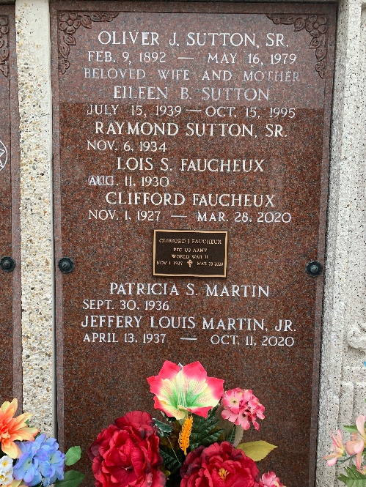
Photo by Team T-Lo

Jeffery L. Martin, Jr. passed away surrounded by his loving family on Sunday, October 11, 2020 at the age of 83. He was a resident of Reserve, LA and a native of Montz, LA. Jeffery was a retiree of E. I. Dupont after more than 33 years of employment.
He was the loving husband of Patricia Sutton Martin. Loving father of Adrienne Tatman (Glenn), Jeffery Martin III, Doug Martin (Renee), Bradley Martin (Angie) and Chris Martin (Corey). Grandfather of Samantha Laborde, Kaitlyn Martin, Crystin Martin, Aleigha Martin, Alijah Martin, Harleigh Martin, Hayes Martin, Corey Cousins, Jeremy Cousins and Sarah Chester. Great grandfather of Rilynn Cousins, Vivian Cousins, Weston Cousins, Ethan Cousins and Oliver Cousins. Son of the late Jeffery L. Martin, Sr. and Regina Millet Martin. Brother of the late Jeanne Martin St. Germain (Leonie) and Elmore Martin (Diane). A private Graveside Service was held in St. Peter Cemetery.
Millet-Guidry Funeral Home, LaPlace, Louisiana
October 17, 2020

