Larry Dale Martin Sr.
October 1, 1935 – December 24, 2023

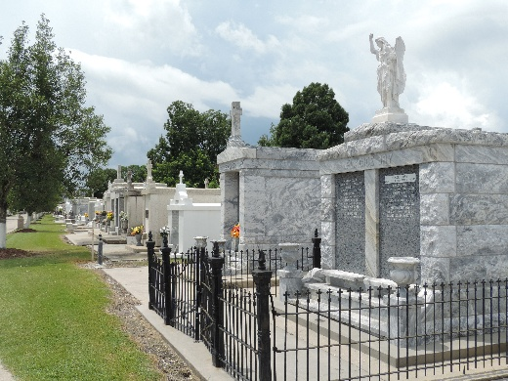

Larry Dale Martin, Sr., a resident of LaPlace, passed away Sunday, December 24, 2023, at the age of 88. He was the beloved husband of Phyllis Smith Martin for 69 years. Loving father and father-in-law of JoAnn Jones (Wayne), Cindy Martin, Patricia Martin (Eugene), Larry Martin, Jr. (Wendy) and Michelle Jensen (Paul). Grandfather of Stacy Tribe (Paul), Kelly Arnett (Willie), Dustin Braud (Katherine), Jamie Fontenot (Adam), Paige Falgoust (Dexter), Larry Martin, III, Jacob, Jordan, Jackson and Joshua Jensen. He was also the great-grandfather of Ian, Adrienne and Emelyn Arnett, Colston and Landon Tribe, Blaze and Jolie Falgoust and John Paul Fontenot. He was the son of the late Elzey and Bibian Martin of Convent, LA.
Larry was a 1953 graduate of Leon Godchaux High School. After graduation he went on to further his love for athletics to play football at Southeastern Louisiana University until experiencing a knee injury.
Larry worked at Shell for 13 years as a machinist and later joined his father running the repair shop at LaPlace Specialty which later became what most know as Martin’s Marine. Many know him through his work in the community, as he served as a juror on the St. John Parish Police Jury for one term, he was a member of the St. John Parish Sheriff’s Office Search and Rescue Division for 16 years and he was an active member at LARAYO with his children and grandchildren.
Larry enjoyed watching LSU football and baseball, but his most joy came from watching his grandchildren play recreational, high school and collegiate sports. He also loved spending time fishing, golfing, gardening and cooking.
His love for his family was endless and he enjoyed a good joke until the end. Larry will be missed by many in his community, but his memory will be held forever in our hearts.
Relatives and friends are invited to attend the Visitation and Funeral Mass on Thursday, December 28, 2023 at St. Joan of Arc Catholic Church, 529 W. 5th Street, LaPlace, LA 70068. Visitation will be held from 10:00 AM to 12:00 PM, with a Funeral Mass at 12:00 PM. Interment will immediately follow in St. Peter Catholic Cemetery in Reserve, LA.

Millet-Guidry Funeral Home, LaPlace, Louisiana

