Phyllis (Smith) Martin
May 29, 1935 – October 16, 2025

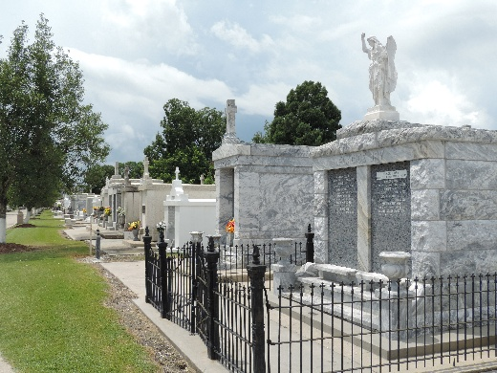

Phyllis Smith Martin, a resident of LaPlace, passed away peacefully at home on October 16, 2025, at the age of 90. She was the beloved wife of Larry Martin Sr. for 69 years. Loving mother and mother-in-law of JoAnn Jones (Wayne), Cindy Martin, Patricia Martin (Eugene), Larry Martin Jr. (Wendy) and Michelle Jensen (Paul). Grandmother of Stacy Tribe (Paul), Kelly Arnett (Willie), Dustin Braud (Katherine), Jamie Fontenot (Adam), Paige Falgoust (Dexter), Larry Martin III (Jasmine), Jacob, Jordan, Jackson and Joshua Jensen. She was also the great-grandmother of Ian, Adrienne, and Emelyn Arnett, Colston and Landon Tribe, Blaze and Jolie Falgoust, and John Paul and Shepard Fontenot. She was the daughter of the late Allen and Solange Smith of Reserve, LA.
Phyllis was a 1953 graduate of Leon Godchaux High School where she reigned as homecoming queen, played basketball, and took pride in her role as a majorette. Her dream of having a family began shortly after getting married where she devoted herself to caring for her children and grandchild-ren, cooking meals, and sharing her kindness throughout the community. She was a social butterfly who enjoyed Carnival Season, LARAYO, Merry Mothers Club, crafting, the casino, volunteering and visiting friends. Her door was always open to welcome you in and if she wasn't in the kitchen, she was running the roads for her family or cheering at baseball games and poolside at swim meets. Her birthday songs, phone calls, and love will be missed by many, but she will rest in peace and will be reunited with her husband, Larry and those who have gone before her.
The family would like to express their heartfelt gratitude to their dedicated caregivers Sandy Watkins, Kina Watkins, April Accomando and the staff at Notre Dame Hospice.
Relatives and friends are invited to attend the Visitation and Funeral Mass on Monday, October 20, 2025, at St. Joan of Arc Catholic Church. Visitation will be held from 10:00 a.m. to 12:00 p.m., with a Funeral Mass at 12:00 p.m. Burial will immediately follow the services at St. Peter Catholic Cemetery.

Obituary published on Legacy.com by Millet-Guidry Funeral Home - LaPlace on Oct. 18, 2025

