Charley Matherne Sr.
September 6, 1889 – August 17, 1964

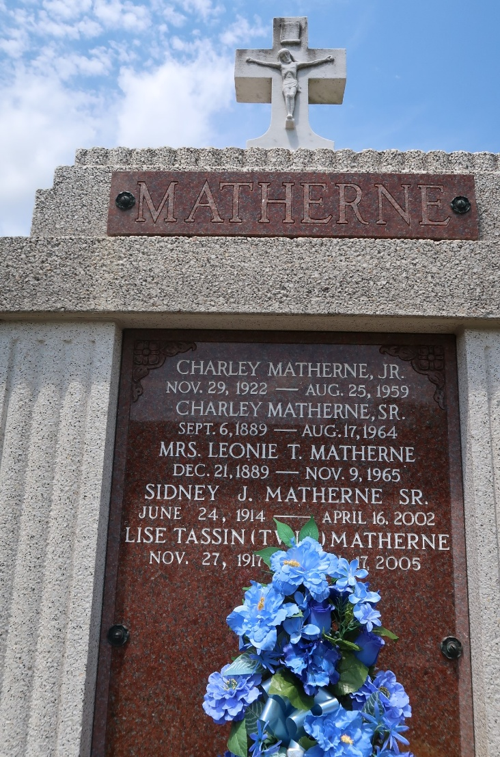

MATHERNE – On Monday, August 17, 1964, at 4:40 o’clock a.m. Charles (Charley) Matherne, beloved husband of Leonie Teamplin, father of Joseph and Adam Matherne of New Orleans, Mrs. Herbert Zeringue of Baton Rouge, La., Mrs. Gary Miller of Hartsville, S.C., Sidney Matherne, Mrs. Robert Brady, Mrs. Alvin Duhon, Mrs. Lewis Cambre of Garyville, La., and the late Charles Matherne Jr. of Baton Rouge, son of the late Elize Frederick and James Matherne, brother of the late Leontine Guidry, Armendine Poche and Leon Matherne, also survived by 53 grandchildren and 15 great-grandchildren, age 75 years, a native of Paulina, La., and a resident of Garyville, La. for 50 years.
Relatives and friends of the family, also employes of National Sugar Co., Reserve, La., Matherne Sheet Metal & Roofing, Shell Oil Co. and Airline Motors are invited to attend the funeral.
Services from Millet Funeral Home, Reserve, La., on Tuesday, August 18, 1964, at 10 o’clock a.m. followed by Requiem Mass at St. Hurbert Church, Garyville, La., at 10:30 o’clock. Interment in St. Peter Cemetery, Reserve, La.

Times-Picayune, New Orleans, Louisiana
Tuesday, August 18, 1964

