Mildred Pauline (Rome) Matherne
June 30, 1912 – June 2, 1981

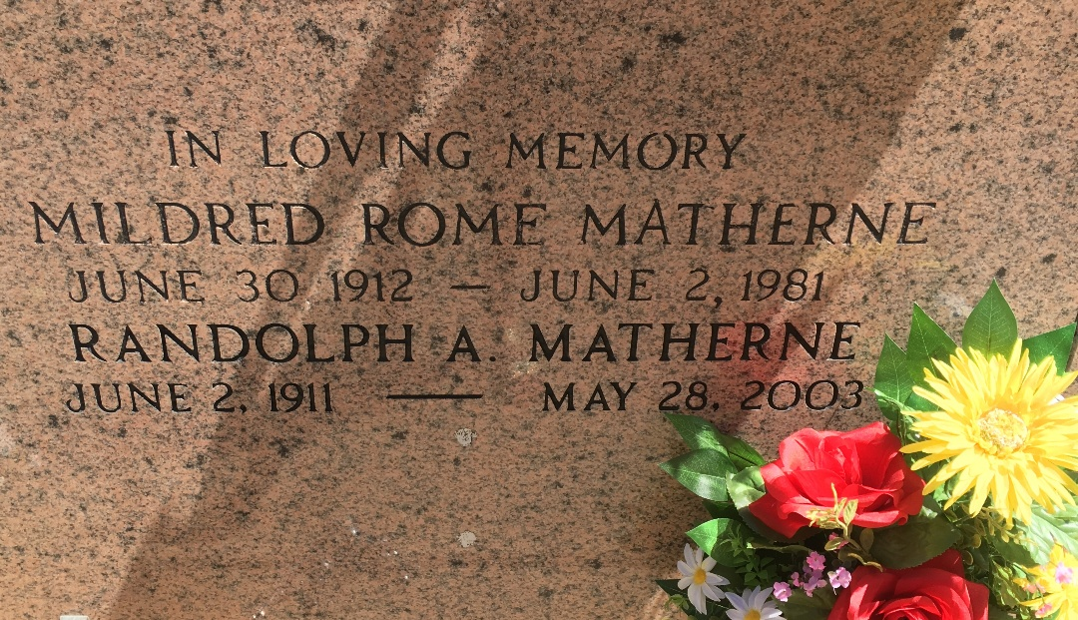
Photo by Team T-Lo

MATHERNE

Mildred Rome Matherne, on Tuesday, June 2, 1981 at 6:50 a.m., beloved wife of Randolph Matherne, mother of Mrs. H. E. Poochie (Joy) Roussell, Mrs. Walter (Gay Neil) Becnel, both of Norco, La., also survived by 6 grand-children, sister of Mrs. Clarence (Myrtle) Torres, age 68, a native of Lutcher and a resident of Garyville for the past 42 years.
Relatives and friends of the family are invited to attend the Funeral Services from Millet Funeral home, Reserve on Thursday, June 4, 1981 at 11:30 a.m. followed by religious services at St. Hubert Catholic Church, Garyville. Interment St. peter Cemetery, Reserve. Friends may call from 5 until 11 p.m. on Wednesday June 3, 1981 and from 8 a.m. until serevices on Thursday.

Times-Picayune, New Orleans, Louisiana
June 3, 1981

