Randolph Albert Matherne
June 2, 1911 – May 28, 2003

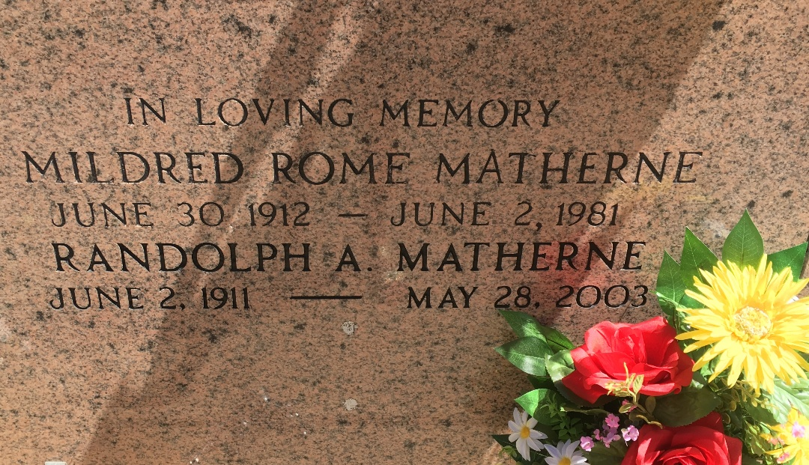
Photo by Team T-Lo

Randolph Albert Matherne on Wednesday, May 28, 2003 at 7:30 AM. Beloved husband of the late Mildred Rome Matherne of 49 years. and currently to Therese Kleibert. Father of Joy M. Roussel and Gay Nell M. Becnel. Father-in-law Hubert (Poochie) Roussel and Walter A. Becnel all of Norco, LA. Grandfather of Randy, Kevin and Craig Roussel, Doreen B. Landry, Celeste B. Stein and Chad Becnel. Great grandfather of Brooke and Madison Stein, Karleigh and Lynleigh Landry, Connor, Cameron and Matthew Roussel. Brother of Irene Braud and the late Hymel, Allen and Evans Matherne. Son of the late Phillip and Jeantine Lambert Matherne. Age 91 years. A native of French Settlement, La. and a resident of Garyville, La. for the past 70 years.

Relatives and friends of the family are invited to attend services. Visitation at St. Hubert Catholic Church in Garyville, La. on Friday, May 30, 2003 from 8:30 AM until 12:00 PM followed by a Mass of Christian Burial at 12:00 noon. Burial in St. Peter Cemetery, Reserve, La. Family wishes to express appreciation to Eagan Home Health Care and Innovations Hospice. Millet Guidry Funeral Home in charge of arrangements.

Times-Picayune, New Orleans, Louisiana
Mary 29, 2003

