Sidney John Matherne Sr.
June 24, 1914 – April 16, 2002

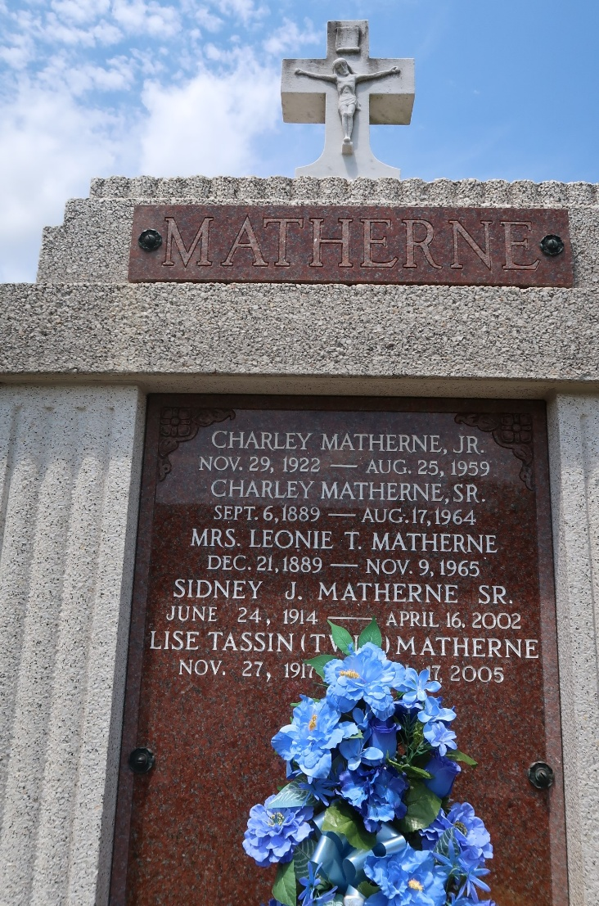

Sidney John Matherne, Sr. on Tuesday, April 16, 2002 at 9:20 p.m. at his home. Beloved husband of 61 years of Lise Tassin Matherne. Father and father-in-law of Sidney John, Jr. and Amber, Douglas M. and Gerry, Phil E. and June, Allen M. and Jody Matherne, Gloria M. and Gordon Tamplain, Sr., Noreen M. and Paul Champagne and Patty M. and Conrad Baker, Sr. Also survived by 19 grandchildren, 33 great-grandchildren and 2 deceased great-grandchildren. Son of the late Charles and Leonie Tamplain Matherne. Brother of Elise Zeringue, Gertrude Brady Walker, Inez Duhon Blank, Eunice Miller, Elsie Cambre, and the late Adam, Joseph and Charles Matherne, Jr.
Mr. Matherne was a retired welder for Shell Oil Norco Refinery of 24 yrs. A member and past Trustee of St. Hubert Church, Lifetime Member of the Holy Name Society and a Member of the Woodman of the World. Age 87. A native of Paulina and a resident of Garyville, LA for the past 58 years.
Relatives and friends of the family are invited to attend the Funeral Services at St. Hubert Catholic Church, Garyville on Friday, April 19, 2002 at 10:00 a.m. Burial in St. Peter Cemetery, Reserve. Visitation from 5:00 p.m. to 10:00 p.m. on Thursday, at Millet Guidry Funeral Home, LaPlace, LA and from 8:00 a.m. until services on Friday at St. Hubert Church, Garyville.

Times-Picayune, New Orleans, Louisiana
April 18-19, 2002

