Appoline (Lemoine) Maurin
July 23, 1905 – April 13, 1983

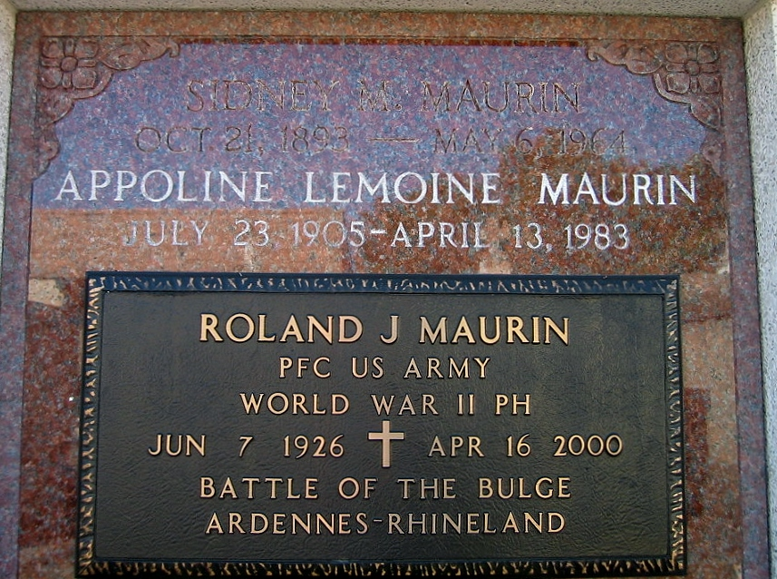
Photo by Bobby

Religious services were held last week for Laplace, Louisiana, native and community leader, Pauline Maurin who died at her niece's home April 13 [1983]. Maurin, who was 77 years old, was an active member of the St Joan of Arc Ladies Altar Society and the Thrift Shop. She was also a member of the Laplace V.F.W. Auxiliary 3337.

Maurin was the mother of Roland (Bolo) Maurin and the sister of Enola Mabile. She is also survived by three grandchildren, R J, Chris and Carolyn Marin and two great grandchildren.

Religious services were held at St Joan of Arc Church with interment in St Peter Cemetery in Reserve.
L'Observateur, LaPlace, Louisiana
21 Apr 1983

