Clemence Eugenie (Jaubert) Maurin
September 18, 1857 – August 28, 1928

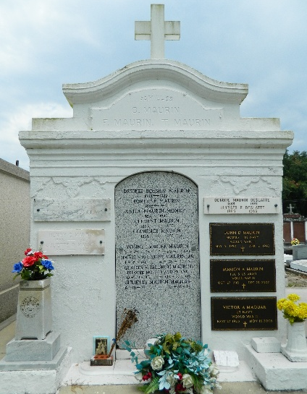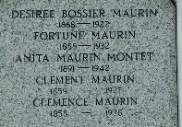

Widow Clement Maurin passed away surrounded by her daughters and son and grandchildren in her home on Tuesday morning 28 Aug 1928, going to the Great Beyond to join her late husband who departed this life in Sep 1927.
Mrs. Maurin, who was Miss Clemence Jaubert before marriage, was born in Basse Alpes, France, on 7 Sep 1857 and was married to the late Clement Maurin in France in 1877. Mr. and Mrs. Maurin left France in the spring of 1878 and came to America making their home in St John the Baptist Parish, Louisiana, where they have resided until their death.
Mrs. Maurin's death came after a prolonged illness of several weeks having been confined to her bed since the month of May. She leaves to mourn her death one son, Henry C. Maurin of Laplace, Louisiana, and three daughters, Mrs. E. P. Feucht and Mrs. K. W. Wilton of Laplace and Mrs. U. E. Deslattes of New Orleans, the following grandchildren: Etienne Jr and Clement Feucht; Cecile, Henry Jr, Marion, Daniel and Juliette Maurin and Shirley Mae Wilton; and two brothers, Ferdinand Jaubert of Lafayette, Louisiana, and Edward Jaubert of Garyville, Louisiana.
The funeral ceremonies will be held at St Peter Catholic Church at Reserve, Louisiana, on 29 Aug 1928 at 9 o'clock mass with interment in St Peter Cemetery, Reserve.

The Times-Picayune, New Orleans, Louisiana
August 29, 1928

