Clement Louis Maurin
November 23, 1859 – September 9, 1927

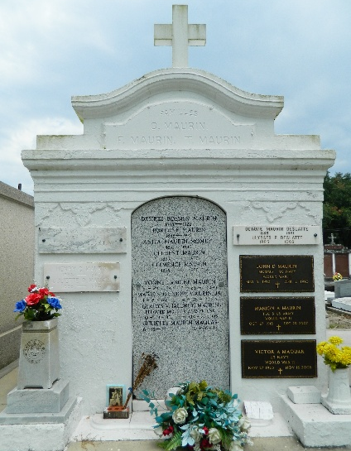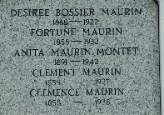

Clement Maurin, founder and head of the firm of C Maurin and Son, died at Laplace, Louisiana, on Friday morning, 9 Sep 1927. He was the son of Jean Louis Maurin and Marie Eleonor Gaudemard, and was born on 24 Nov 1858 at 4 am at Jausiers, Dept of Alpes-de-Haut-Provence, France, and listed as Louis Clement Maurin in his birth registration. He married Marie Eugenie Clemence Jaubert, also a native of Jausiers, on 30 Jan 1878 at Sanieres, Alpes-de-Haut-Provence, France.

Services were Saturday 10 Sep 1927 at St Peter Church, Reserve, Louisiana, with interment in St Peter Cemetery, Reserve. Pallbearers were Fortune Jaubert and George Jaubert of New Orleans, Dr. E. P. Feucht and K. W. Wilton of Laplace, Louis J. Maurin of Reserve, Ulysses Deslattes of New Orleans, Fortune Maurin of Reserve and Sidney Maurin of Laplace.

The Times-Picayune, New Orleans, Louisiana
September 12, 1927

