Desiree (Bossier) Maurin
1868 – February 8, 1922

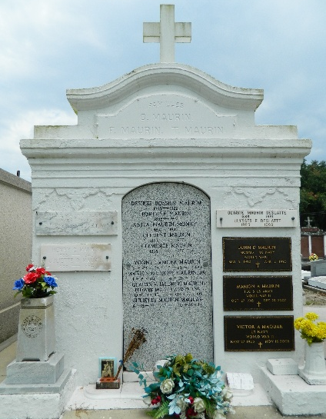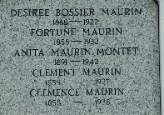

Mrs. Fortune Maurin, formerly Miss Desire Bossier, died at her home at Reserve, Louisiana, after a long illness of several months. Her funeral took place at St Peter Catholic Church at Reserve with interment in St Peter Cemetery.

She is survived by her husband, Fortune Maurin of Reserve, two brothers, Paul Bossier of Sellers, Louisiana, and Pamphile Bossier of West Baton Rouge, Louisiana, and the following children: Mrs. Maurice Granier of Laplace, Louisiana, Mrs. Henry Donaldson, Louis J, Fortune Jr, Horace and Etienne, all of Reserve.

The Times-Picayune, New Orleans, Louisiana
February 10, 1922

