Emma Marie (LeBrun) Maurin
December 26, 1891 – February 15, 1958

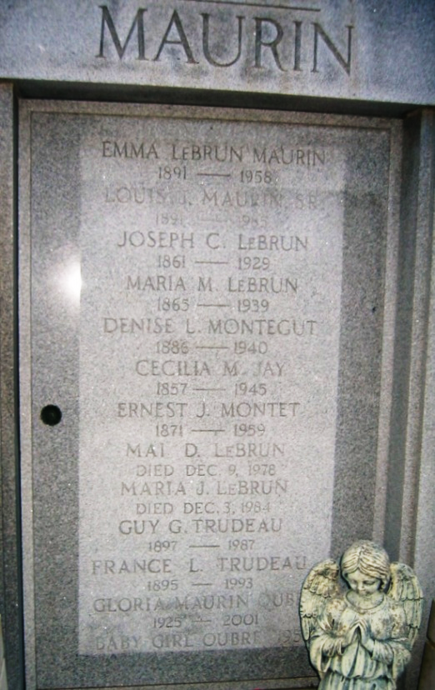
Photo by Bobby

MAURIN - In New Orleans, La, on Saturday, February 15, 1958, at 3:55 o'clock p.m., EMMA MARIE LE BRUN, beloved wife of Louis J Maurin Sr; mother of Mrs. Dewey DeLaneuville, Mrs. John W. McTopy, Louis J. Maurin Jr, Mrs. Armand M. Montz Jr, Mrs. Richard Oubre, J LeBrun Maurin and Mrs. Warren C Montz; sister of Mrs. Guy G Trudeau, Mai and Maria Le Brun and the late Mrs. J. J. Montegut; niece of Ernest Montet; also survived by 16 grandchildren; aged 66 years 1 month and 20 days.
Relatives and friends of the family are invited to attend the funeral which will take place on Monday, February 17, 1958, at 10:30 o'clock a.m. from the Millet funeral home, Reserve, La, followed by Requiem High Mass at St Peter's church, Reserve, La. Interment in St Peter's cemetery.

The Times-Picayune, New Orleans, Louisiana
February 17, 1958, p. 2

