Eugene Joseph Maurin
June 29, 1932 – August 8, 2008

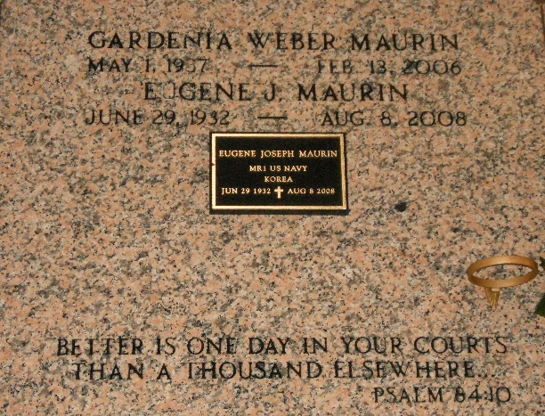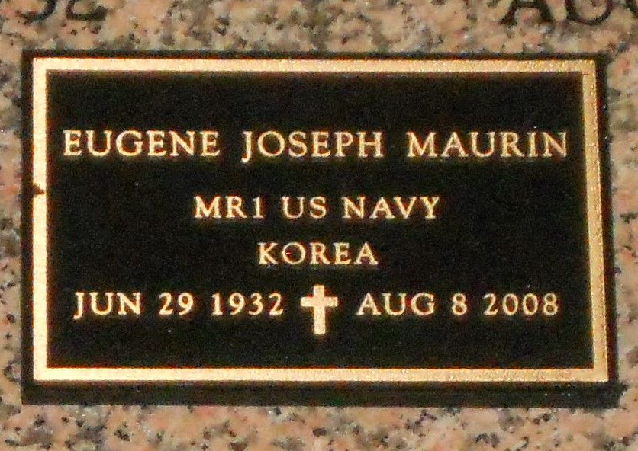
Photo by Team T-Lo

Eugene Joseph Maurin on Friday August 8, 2008 at 4:30AM. Beloved husband of the late Gardenia Weber Maurin. Father of Kenneth Maurin and wife Kim, Stephanie Cox and husband Jeffrey, Barbara Maurin and the late Stephen Maurin. Grandfather of Keith Maurin, Jeremy and Samuel Cox and the late Brianne Maurin. Son of the late Horace and Rosa Donaldson Maurin. Brother of Horace (Sonny), Jr., Lois Abadie, Michael Maurin and the late Don and Margaret Maurin. Age 76 years. A native and resident of Reserve, LA.

Relatives, friends and members of VFW Post #5004, Reserve, LA and the American Legion are invited to attend services. Visitation at Millet-Guidry Funeral Home, 2806 W. Airline Hwy., LaPlace, LA on Tuesday, August 12, 2008 from 9:00AM to 11:00AM. Followed by Memorial Services at the Funeral Home Chapel at 11:00AM. Burial in St. Peter Cemetery, Reserve, LA.

The Times-Picayune, New Orleans, Louisiana
August 10, 2008

