Fortune Hyacinthe Maurin Sr.
November 29, 1854 – June 25, 1932

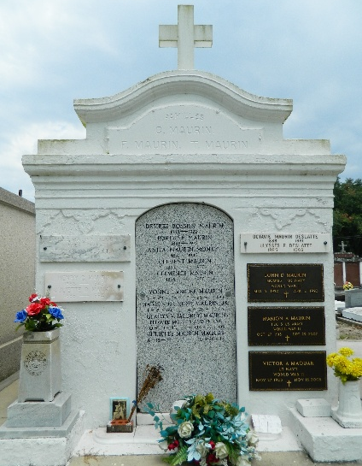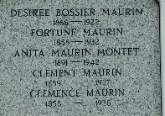

Born 29 Nov 1854 at Enchastrayes, Alpes-de-Haut-Provence, France to Jean Louis Maurin and Marie Eleanore Gaudemard. He died on Saturday morning, 25 Jun 1932, at 9 o'clock.

Husband of the late Desire Bossier and father of Louis, Horace and Fortune Jr, Etienne and Mrs. Henry Donaldson and Mrs. Maurice Granier.

Funeral services were Sunday 26 Jun 1932 with interment in St Peter Cemetery, Reserve, Louisiana.

The Times-Picayune, New Orleans, Louisiana
June 26, 1932

