Gardenia Mae (Weber) Maurin
March 1, 1937 – February 13, 2006

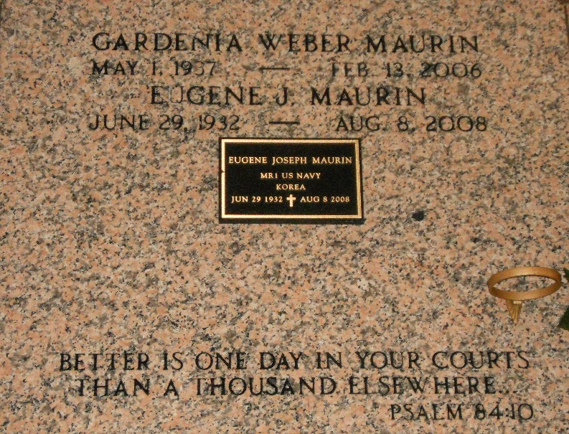
Photo by Team T-Lo

Gardenia Weber Maurin on Monday, February 13, 2006 at 9:00 a.m. Beloved wife of Eugene Maurin. Mother and mother-in-law of Kenneth and Kim Maurin, Stephanie and Jeffrey Cox, Barbara Maurin and the late Stephen Maurin. Loving grandmother of Keith Maurin, Jeremy and Samuel Cox, and the late Brianne Maurin. Daughter of the late Garland and Ethel Weber. Sister of Garnet Russel, Gene Michael Weber and the late Garland Weber, Jr. Age 68. A native of New Sarpy, LA and a resident of Reserve, LA for the past 45 years.

Relatives and friends of the family are invited to attend services. Visitation at St. Peter Catholic Church, Reserve, LA on Thursday, February 16, 2006 from 10:00 a.m. until 12:00 noon. Followed by Religious Services at the Church at 12:00 noon. Burial in Church Cemetery. Arrangements by MILLET-GUIDRY FUNERAL HOME, LaPlace, LA.

The Times-Picayune, New Orleans, Louisiana
February 15, 2006

