Henry Clement Maurin Sr.
June 17, 1885 – February 10, 1943

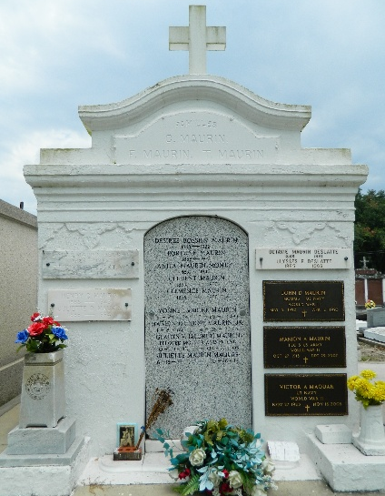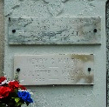

Henry Clement Maurin Sr, prominent for more than a quarter century in business, political and fraternal affairs of St John the Baptist Parish, Louisiana, died Wednesday at 6:10 am at his home in Laplace. Mr. Maurin, who was 57 years old, had been correspondent in Laplace for The Times-Picayune for 30 years. Born near Laplace on 17 Jun 1885, he was educated at Jefferson College, Convent, Louisiana, and upon his graduation in 1903, became associated with the firm of Clement H. Maurin and Son in capacity of business manager. In 1911 he married Miss Juliette Ory of Laplace.
He took the initiative in organizing the Louisiana Police Jury Association in 1924 and became its first secretary, holding the position until 1936. Also in 1924, he became identified with the St John the Baptist Parish Police Jury, serving as its executive secretary until 1936.
From 1934 until 1940, Mr. Maurin was a field representative of the state department of revenue. He left this position to become secretary of the St John the Baptist Parish local Selective Service Board, which position he held at the time of his death.
He fostered organization of the Laplace Chamber of Commerce and became secretary-treasurer in 1940. On May 1927, Mr. Maurin was commissioned a notary public by Governor O H Simpson.
A charter member and founder of the John A. Reine Camp No. 504, Woodman of the World, he was elected council commander in 1910 and held that post for 33 years. He also was a member of the Benevolent Knights of America and a member of the board of trustees of St Peter's Council No. 2436, Knights of Columbus. A charter member of the later organization, he served as its first financial secretary.
In addition to his widow, he is survived by three sons, Henry C. Maurin Jr. with the army in the Hawaiian Islands, Marion Maurin, with the army in Texas, and John Daniel Maurin, with the navy in California, two daughters, Cecile and Juliette Maurin, and three sisters, Mrs. E. P. Feucht of Laplace, Mrs. Ulysee Deslatte of New Orleans, and Mrs. K. W. Wilton of Laplace.

The Times-Picayune, New Orleans, Louisiana
February 11, 1943

