Joseph Theodore Maurin
January 8, 1844 – September 25, 1914

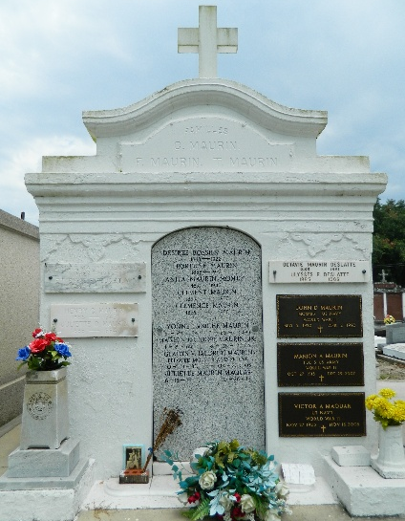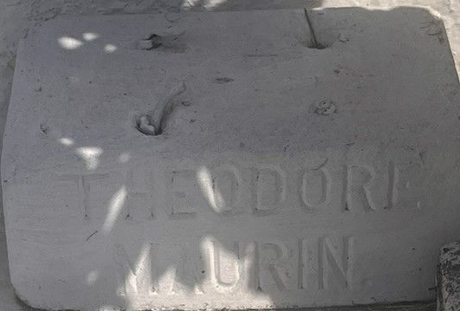

Joseph Theodore Maurin, a native of Uvernet, Alpes-de-Haut-Provence, France, died at this home near Reserve, Louisiana, on Friday, 25 Sep 1914. As a young man in France, he served in the Prussian War of 1870 and was taken prisoner in the Battle of Sedan. Upon completion of his service in the French army, he immediately re-enlisted for another term from which he was honorable discharged.
In 1875 he left France, landed in New Orleans, and came to St John the Baptist Parish, Louisiana, entering the mercantile establishment of J Teissier serving as a clerk until the following year when he entered the mercantile establishment of Alphonse Maurin, his brother, and Leon Graugnard. He worked for them until the early 80s when Alphonse Maurin returned to France, leaving his place to be filled by Joseph.
In 1889 Joseph married Octavie Jaubert and they were the parents Anita and Sidney Maurin, who survive. His wife died in 1892. He is also survived by four brothers, Fortune Maurin and Clement Maurin, both residents of this parish, and Antoine and Alphonse, both residents of France.
Funeral services were held 26 Sep 1914 at St Peter Church in Reserve with interment in St Peter Cemetery.

Dwayne Montz

