John Daniel Maurin Sr.
May 2, 1922 – April 2, 1993

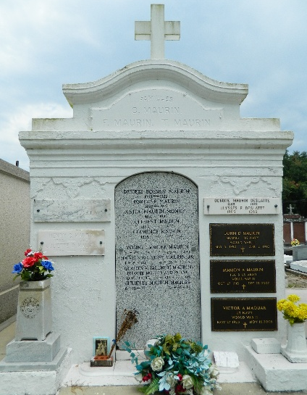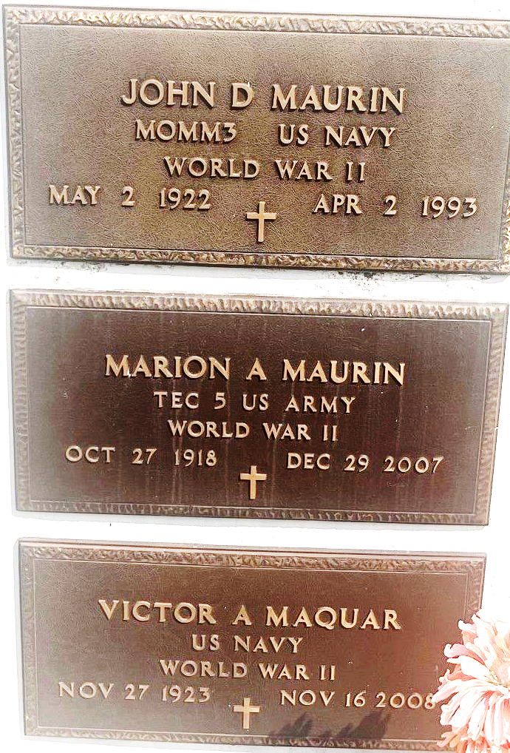

John Dan (Sam Spade) Maurin Sr. died on Friday 2 Apr 1993 at 9:00 pm at age 70 years. He was a native and resident of Laplace, Louisiana, and the husband of Gladys Vicknair Maurin. He was the father of J. D. Maurin Jr., Gregory M. Maurin and Linda M. Stein. Also survived by 6 grandchildren.

He was the brother of Marion (Poose) Maurin, Cecile Cambre, Juliette Maquar and the late Henry (Foot) Maurin.

Services were Monday, 5 Apr 1993 at St Joan of Arc Church, Laplace, with interment in St Peter Cemetery, Reserve, Louisiana.

The Times-Picayune, New Orleans, Louisiana
April 4, 1993

